
Centers for Medicare & Medicaid Services (CMS)
CCIIO Enrollment Resolution & Reconciliation (ER&R), Form 1095-A Data Reporting
Volume I – Technical Proposal
Request for Quote (RFQ): 75FCMC26Q006875FCMC26Q0068
May 07, 2026
Submitted By:
Deloitte Consulting LLP | 1919 North Lynn Street | Arlington, VA 22209

Centers for Medicare & Medicaid Services (CMS)
CCIIO Enrollment Resolution & Reconciliation (ER&R), Form 1095-A Data Reporting
Request for Quote (RFQ): 75FCMC26Q0068
Volume I – Technical Proposal
May 07, 2026
Submitted by:

Deloitte Consulting LLP , 1919 North Lynn Street, Arlington, VA 22209

Submitted to:
Amberly Kovalick, Contracting Officer
Email: Amberly.Kovalick@cms.hhs.gov.
Megan Famodu, Contract Specialist
Email: Megan.Famodu @cms.hhs.gov
DIV OF MEDICARE & MARKETPLACE CONTRACTS,
CMS - OAGM
7500 SECURITY BOULEVARD, MS: B3-30-03
BALTIMORE, MD 21244-1850

Submitted by:
Technical POC and  Authorized Negotiator:  Matt Siegel, Managing Director  Tel. +1 (617) 437-2646  Email: masiegel@deloitte.com | Contracts POC:  Teresa Sage, Contracts Administrator  Tel. +1 (571) 814-7707  Email: tsage@deloitte.com  Reference Number: JO-069714

This proposal or quotation includes data that shall not be disclosed outside of the Government and shall not be duplicated, used, or disclosed in whole or in part for any purpose other than to evaluate this proposal or quotation. If, however, a contract is awarded to this Offeror or Quoter as a result of or in connection with the submission of this data, the Government shall have the right to duplicate, use, or disclose the data to the extent provided in the resulting contract. This restriction does not limit the Government’s right to use information contained in this data if it is obtained from other sources without restriction. The data subject to this restriction are contained in this entire proposal.

May 07, 2026
Amberly Kovalick, Contracting Officer
Megan Famodu, Contract Specialist
DIV OF MEDICARE & MARKETPLACE CONTRACTS,
CMS - OAGM
7500 SECURITY BOULEVARD, MS: B3-30-03
BALTIMORE, MD 21244-1850
RE: | Request for Proposal (RFP): 75FCMC26Q0068, CCIIO Enrollment Resolution & Reconciliation (ER&R), Form 1095-A Data Reporting
Dear Ms. Kovalick and Ms. Famodu:
Deloitte is pleased to submit our proposal to provide Enrollment Resolution & Reconciliation (ER&R), Form 1095-A Data Reporting to the Centers for Medicare & Medicaid Services (CMS). We believe that our submission meets all of the requirements of the request, and demonstrates that Deloitte possesses the required level of skill and experience to perform the Statement of Work (SOW). Centers for Medicare & Medicaid Services (CMS)
We are excited by the prospect of working with you, and we hope our proposal conveys our enthusiastic commitment to provide distinctive client service and highly specialized talent to this project. Our submission consists of 4 volumes: Volume I: Technical Quote, Volume II: Business Quote, Volume III: Conflict of Interest, and Volume IV: Section 508 Compliance.
We look forward to working with you to achieve optimum value to the Centers for Medicare & Medicaid Services (CMS). If you have any questions or require additional information, please contact me at +1 (617) 437-2646. Should you have any contractual questions, please contact Teresa Sage, Contracts Administrator, +1 (571) 814-7707.Centers for Medicare & Medicaid Services (CMS)
Sincerely,

Matt Siegel, Managing Director
Deloitte Consulting LLP

Table of Contents
1.0 Section 1: Technical Understanding and Approach (Total 40 Pages) 1
1.1 Sub-Section 1A: Understanding of CMS’ Program and Acquisition Objectives 1
1.2 Sub-Section 1B: Approach to Performing the Requirements in the SOW 1
1.2.1 Task 2: ER&R Issuer Disputes ^{(SOW 3.2)} 1
1.2.2 Task 3: Form 1095-A Consumer Disputes ^{(SOW 3.3)} 1
1.2.3 Task 4: Complex Case Help Center (CCHC) ^{(SOW 3.4)} 1
1.2.4 Task 5: Updating the FFE ^{(SOW 3.5)} 1
1.2.5 Task 6: Notice Generation ^{(SOW 3.6)} 1
1.2.6 Task 7: Telephone and Correspondence Support ^{(SOW 3.7)} 1
1.2.7 Task 8: IT Systems ^{(SOW 3.8)} 1
1.2.8 Task 9: Standard Operating Procedures (SOPs) Business Requirements and Quality Assurance^{(SOW 3.9)} 2
1.2.9 Task 10: Ad Hoc Work and Special Projects^{(SOW 3.10)} 2
1.3 Sub-Section 1C: Understanding and Mitigation of Risks 2
2.0 Section 2: Management Approach, Quality Assurance and Surveillance Plan, and Staffing Plan 3
2.1 Sub-Section 2A: Management Approach 3
2.1.1 Task 1: Program Implementation and Oversight (PI&O) ^{(SOW 3.1)} 3
2.1.2 Task 11: Transition-Out (Optional) ^{(SOW 3.11)} 3
2.1.3 Task 12: Transition-In (Optional) ^{(SOW 3.12)} 3
2.2 Sub-Section 2B: Quality Assurance Approach 3
2.3 Sub-Section 2C: Staffing Plan 4
3.0 Section 3: Key Personnel Qualifications and Corporate Experience 4
3.1 Sub-Section 3A: Key Personnel Qualifications 4
3.2 Sub-Section 3B: Corporate Experience 5
4.0 Section 4: Small Business Utilization (5 Pages) 1
Appendix A Key Personnel Resumes (2 Pages Each) A-1
A.1 Project Director A-1
A.2 Project Manager (ER&R) A-2
A.3 Project Manager (Form 1095-A & CCHC) A-3
A.4 Project Manager (IT Data and Technical Support) A-4
A.5 Technical Director A-5
A.6 Security and Privacy Officer A-6
List of Acronyms and Abbreviations 8
Compliance Matrix 10
List of Figures

List of Tables
Table X.X-X. Provide Title. 1

1.0 Section 1: Technical Understanding and Approach (Total 40 Pages)

1.1 Sub-Section 1A: Understanding of CMS’ Program and Acquisition Objectives (1 Page)
Our approach to this requirement aligns directly with the core mission of the Centers for Medicare & Medicaid Services (CMS) and the Center for Consumer Information and Insurance Oversight (CCIIO): to implement the Affordable Care Act's private insurance provisions and ensure Americans have reliable access to high-quality, affordable healthcare. We recognize that robust enrollment resolution and reconciliation (ER&R) is the operational linchpin of this mandate. Resolving data discrepancies across the CMS Data Services Hub (DSH), State-Based Marketplaces, and the issuer community is far more than an administrative IT task. It is the vital mechanism that keeps over 24 million Marketplace enrollees connected to their doctors, ensures Advance Premium Tax Credits (APTC) are perfectly calibrated, and prevents devastating tax liabilities. Deloitte is committed to bringing a refreshed methodology to sustain and modernize these mission-critical workstreams — treating program integrity not as a compliance obligation layered on top of operations, but as a design principle embedded in every platform control, business rule, workflow, and quality checkpoint — proactively identifying and neutralizing fraud, waste, and abuse before it propagates into casework, payments, or tax reporting, safeguarding federal taxpayer dollars and the health and financial security of consumers.
We bring a 360-degree perspective to this challenge, built upon our successful delivery of resolution and reconciliation solutions for five State-Based Marketplaces (SBMs) and leading national issuers such as Anthem and Kaiser Permanente. To address the full scope of CCIIO’s Statement of Work, we scale this state and commercial agility to the federal level by deploying a frontline workforce of highly experienced caseworkers equipped with modernized telephony and omnichannel support systems. By combining this human-centric operational expertise with comprehensive systems integration, advanced data analytics to detect and prevent improper payments, and Agile delivery, we ensure complex consumer disputes and Form 1095-A inquiries are resolved swiftly and accurately. Today, CMS, HHS, and the IRS trust Deloitte to secure, stabilize, and innovate their most complex, large-scale operations.
Deloitte understands CMS' primary objective for this acquisition is to partner with a System Integrator capable of maintaining the operational stability of the ER&R program while actively driving innovation, efficiency, and continuous improvement to achieve the following:a
Strategic Objective | Strategic Outcome
Uncompromising Enrollment Data Integrity | Deloitte will serve as the central steward of enrollment and financial data accuracy across the Federally facilitated Exchange (FFE) and all State-Based Exchanges (SBEs). We will systematically reconcile issuer data, accelerate discrepancy resolution, and ensure all corrections are seamlessly synchronized with the FFE. By empowering issuers to resolve disputes efficiently, we facilitate timely, accurate payments and enable the rapid cancellation of erroneous enrollments. Our ultimate outcome: the right enrollee is in the correct plan, receiving the precise amount of financial assistance, month after month.
Seamless Consumer Experience & Tax Accuracy | Deloitte will safeguard Marketplace enrollees' ability to file their federal taxes accurately and maintain their health coverage without disruption. We will resolve Form 1095-A disputes with urgency and precision—dynamically scaling our workforce to meet peak tax-season demands. Furthermore, we will ensure that consumers facing the most complex enrollment barriers receive dedicated, expert assistance through the Complex Case Help Center (CCHC), delivering lasting root-cause resolutions rather than mere case closures.
Technology modernization & AI innovation | Deloitte will continuously advance the technical capabilities that power the ER&R mission. We will modernize core systems—including CERRS, HICS, SEED, and EDA CORE—on a secure, Azure cloud-native architecture. To accelerate discrepancy resolution and system maintenance, we will integrate AI-driven innovations to streamline complex operational activities, ensuring full algorithmic transparency is documented in the PIOP. Concurrently, we will build an advanced data analytics infrastructure that empowers CMS and issuers with real-time visibility into enrollment alignment. We will treat every Agile release cycle as a strategic opportunity to reduce manual burden, improve system reliability, and deliver measurable, rapid-turnaround efficiency gains to the program.
Uncompromising Security, Privacy & Regulatory Compliance | Deloitte will partner with CCIIO to rigorously safeguard the sensitive personal, health, and tax information (PII, PHI, and FTI) entrusted to the ER&R program. To protect the system infrastructure from malicious users and evolving cyber threats, we will implement proactive, robust defenses while achieving strict security compliance. We will maintain continuous Authorizations to Operate (ATOs) without disruption and ensure our entire workforce is fully vetted and credentialed prior to accessing any CMS system. We commit to executing rapid incident response protocols within stipulated SLAs, treating the defense of enrollee data not merely as a compliance obligation, but as a fundamental commitment to the security and trust of the CMS and CCIIO.
Excellence in Program management & stakeholder partnership | Deloitte will operate as a true partner to CMS, ensuring complete, real-time visibility into the health of the ER&R program. Through disciplined governance and proactive communication, we will execute deliverables flawlessly, anticipating and mitigating risks before they materialize into issues. We are acutely aware of the stakes of contractor transitions; we will manage every phase of the handover with rigorous precision, guaranteeing that operational changes never translate into disruptions for the 24 million people relying on the Marketplace.
Protect against fraud, waste, and abuse
- Deliver uninterrupted operations across all three workstreams — Enrollment Resolution & Reconciliation (ER&R), Form 1095-A Data Reporting, and the Complex Case Help Center (CCHC) — protecting the more than 24 million Marketplace consumers who depend on accurate enrollment, payment, and tax data from the first day of contract performance.
- Modernize the operating model through automation, AI-assisted casework, governed business-rule lifecycle management, and program-integrity-by-design controls — reducing manual effort, accelerating dispute resolution, and detecting fraud, waste, and abuse before improper payments and tax errors propagate downstream.
- Strengthen the FFE/SBE issuer ecosystem through transparent reporting, structured technical assistance, and proactive program intelligence — turning each dispute, casework trend, and 834 anomaly into a CMS-actionable recommendation rather than a backward-looking trend observation.

1.2 Sub-Section 1B: Approach to Performing the Requirements in the SOW (Total 18 Pages)

1.2.1 Task 2: ER&R Issuer Disputes ^{(SOW 3.2)} (2 Pages)
Deloitte’s operating philosophy follows a deliberate phased approach to inheriting the ongoing ER&R operations. In the first horizon, Deloitte team is ready to deliver operational stability from Day 1; smooth transition, no disruption to in-flight cases, and serving consumers is a responsibility we do not take lightly. We achieve this through collaboratively working with CMS and its contractors, issuers, executing a smooth knowledge transfer and the use of technology provide additional system insight above and beyond what is already documented in the SOPS. Deloitte applies structured assessment and optimization -- improving rule performance, refining staffing models, and strengthening program intelligence -- with CMS visibility and approval at each step.
Program integrity is not a compliance layer in this operating model. It is a design principle embedded in every task from Day 1. Audit-ready case documentation, documented approval before any override or batch correction, elevated QA sampling for high-risk case types, and a cross-task integrity risk register established during transition-in are operational standards, not periodic reviews. Deloitte will surface integrity findings to CMS with root cause analysis and recommended corrective action -- not after an audit, but as a routine output of the operating model.

Shared Transition-In Approach: Tasks 2, 3, and 4
Deloitte operates ER&R, 1095-A and Complex Cases as an integrated ER&R program. An issuer data error becomes a payment dispute in Task 2 and a consumer tax problem in Task 3. An upstream system condition appears in Task 4 before it surfaces in aggregate dispute data. Deloitte's operational approach makes those connections visible in real time -- one coordinated response, one CMS briefing.
Deloitte will be operationally ready before the first case transfers. The transition-in approach -- detailed under Task 12 -- validates every system, workflow, and intake pipeline against live production behavior. Deloitte deploys TruNorth, our proprietary GenAI platform, to independently capture rule logic, routing rules, and classification behavior directly from source code across all tasks simultaneously -- producing a system understanding that supplements what is shared through SOPs and KT. This will give CMS the confidence in the transition being built on the solid foundation. Every function is validated through a structured readiness gate before going live, with progress confirmed through a daily cross-task dashboard that makes readiness visible and measurable to CMS throughout the transition period.
Deloitte brings pre-existing knowledge of the enrollment reconciliation and 1095-A through our work with the States and issuers and staffs each task with personnel who arrive scenario-trained on the actual case types, system configurations, and issuer patterns they will encounter. Each task's Key Personnel leads the knowledge transfer process for their workstream. The knowledge transfer model moves through four structured stages before any caseworker handles a live case. From Day 1, a weekly cross-task data share connects all three teams so patterns that originate in one workstream and surface in another are coordinated as a single corrective action -- not discovered independently weeks apart.
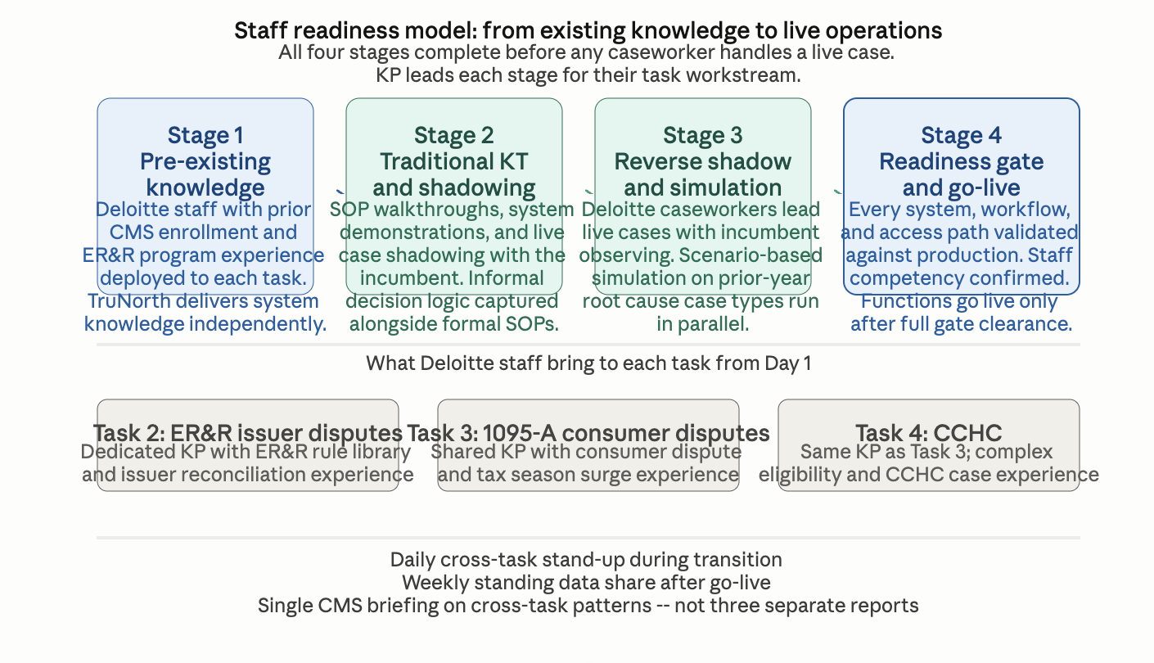
An integrity risk register covering all three tasks is established during transition-in, with control points and escalation playbooks for high-risk workflows documented before Day 1.
What the incumbent cannot offer at transition: The incumbent's knowledge of how these systems actually operate is experiential and partially captured in SOPs. TruNorth captures the same knowledge from the source code in weeks, independently, across all three tasks simultaneously. Deloitte arrives at contract start with a system understanding that the incumbent took years to accumulate -- and a daily transition cadence that makes readiness visible and measurable rather than assumed.

Our Understanding
Issuers depend on the ER&R dispute process to keep their enrollment and payment records aligned with the FFE. When the process runs well, issuers can reconcile efficiently, payment data stays accurate, and the downstream effects on consumer 1095-A forms and APTC payments remain clean. When it does not, the consequences compound: unresolved payment disputes create issuer financial exposure, enrollment mismatches produce incorrect tax statements, and the volume of downstream consumer disputes grows. The operational standard for this workstream is accuracy, consistency, and a feedback loop that tells CMS where the upstream reconciliation process is breaking down before the downstream consequences appear.
What makes this workstream hard to run well is the simultaneous demand for automation at scale and judgment in complexity. The approximately four million low-complexity disputes processed annually require a rule library that is accurate, well-maintained, and monitored at the dispute-type level -- not in aggregate. The high-complexity workload, including UIRs, PDI disputes, and cases requiring manual enrollment reconstruction, demands caseworker judgment that is consistent, documented, and auditable. Deloitte has operated high-consequence, rule-governed enrollment and payment environments at scale in federal health programs -- [insert relevant proof point program names here]. Our California SBE Maintenance and Operations takeover in 2019 is a direct precedent: Deloitte inherited a live operational system, validated production behavior independently of prior contractor documentation, and improved performance without disrupting the ongoing operation.

Our Approach
Deloitte operates Tasks 2.1 and 2.2 as a single integrated function — automated rule-based resolution at scale on the left, structured manual casework on the right, with exceptions flowing between them and dispute intelligence continuously feeding upstream improvements. The model below shows how both lanes operate and how what Deloitte learns from running them makes the program measurably better over time.
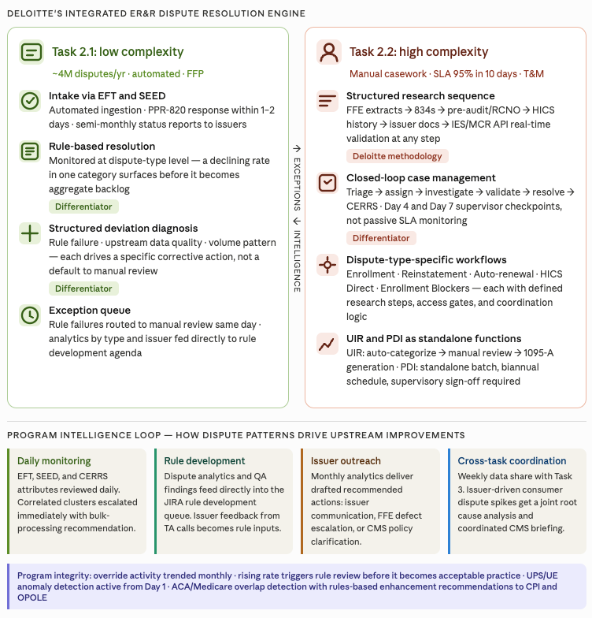

Low complexity (Task 2.1)
Deloitte will operate the automated rule library from Day 1 at the performance baseline established during transition-in. When a resolution rate deviates, Deloitte will diagnose whether the cause is a rule performance failure, an upstream data quality issue, or a volume pattern the rule was not designed to handle — each drives a different corrective action. The dispute analytics deliverable serves as both a CMS reporting output and Deloitte’s internal rule development agenda, made visible to CMS.
Enhancing automated rule library
Deloitte will manage the business rule library as a governed lifecycle: every rule change moves through a structured process shown below.

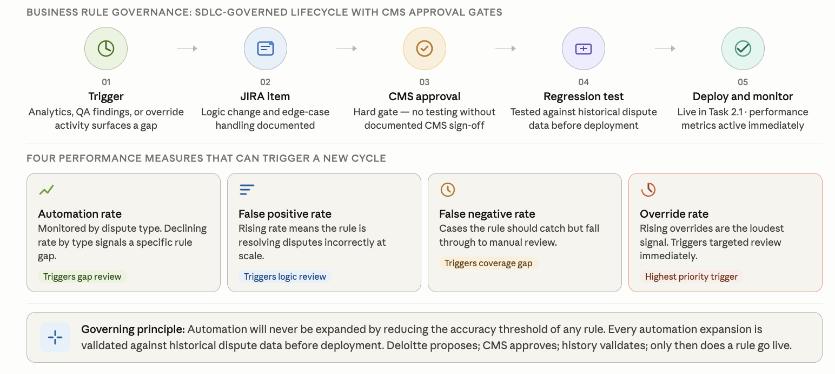

High complexity (Task 2.2): closed-loop case management
Deloitte manages every high-complexity case through a closed-loop workflow with governance gates at each stage. The process flow and research sequence below show how each case moves from intake to CERRS closure, and how supervisors intervene timely so disputes are resolved within the specified time.

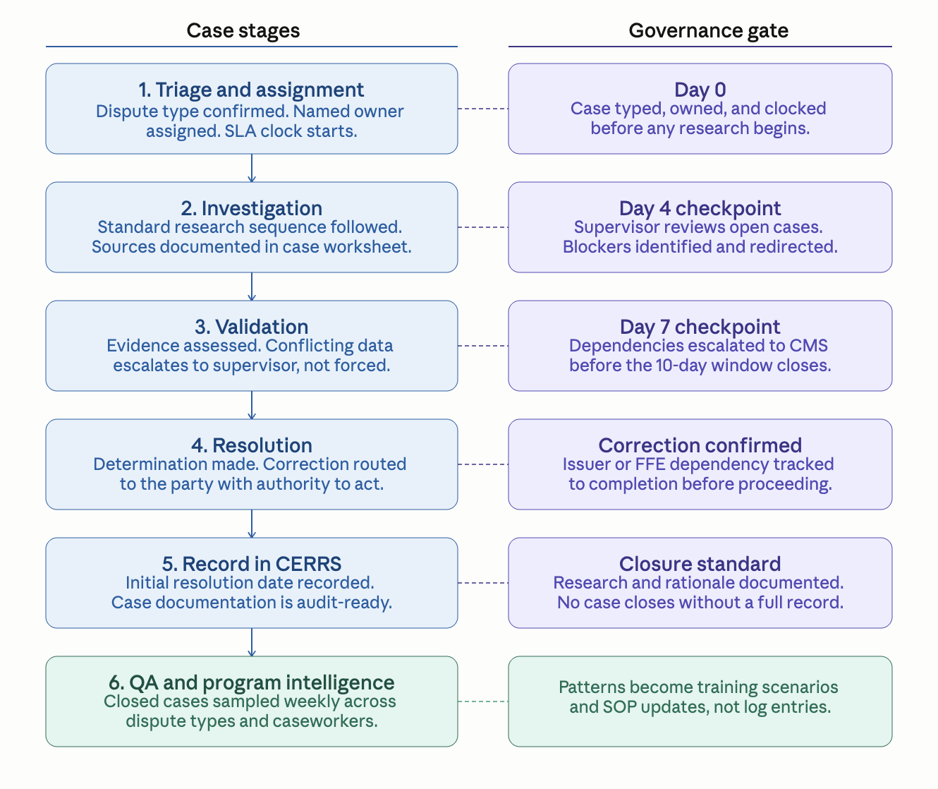
Deloitte's participation in daily operational reconciliation workgroup calls is an intelligence input, not an attendance obligation. Issues surfaced in those calls feed directly into the JIRA rule development backlog and the dispute analytics cycle, so CMS can remain confident that dispute patterns are being addressed methodically. Below is Deloitte’s approach to processing various dispute types.
Dispute type | Deloitte’s approach
Enrollment, Reinstatement, Auto-renewal, HICS Direct | Defined research steps per type: FFE extracts, 834s, pre-audit/RCNO, HICS history, issuer docs, IES/MCR API real-time validation at any step. Access gates and coordination logic applied to each.
Enrollment Blockers | Sustained cross-contractor coordination required. Deloitte tracks dependencies and drives resolution rather than waiting for external parties.
UIR records | UIR categorization accuracy matters because the category determines the issuer's resolution path — a miscategorized record generates a second dispute cycle. Deloitte's manual review step for uncategorized UIRs applies documented decision criteria rather than individual caseworker judgment, and every categorization decision is subject to QA sampling before the monthly report is issued.
PDI disputes | PDI disputes are governed as a standalone workflow because their regulatory deadline sensitivity means a processing error cannot be corrected through a routine cycle — supervisory sign-off is required before any biannual batch submission by Deloitte’s team.

Quality, issuer engagement, and program intelligence
QA is applied at the case level: closed cases sampled weekly across research completeness, determination accuracy, documentation, and consumer notification confirmation. APTC determinations, retroactive adjustments, and override actions are sampled at an elevated rate given downstream consequence. When QA surfaces an inconsistency, the finding becomes a training scenario and an SOP update. Technical assistance calls with issuers (3–4 per month) follow a structured agenda Deloitte prepares in advance. Every recurring pain point is logged as a JIRA item, categorized by whether the root cause is a rule gap, a data quality issue, or an issuer-side process failure — because each has a different resolution path. Issuers see their feedback is leading to process improvements through the reduction of disputes and friction in the interfaces.

Trend detection and program integrity
Deloitte will treat the incoming dispute queue as a live intelligence signal from Day 1, with daily monitoring and a monthly analytics cycle that delivers recommended actions to CMS rather than trend observations.
What Deloitte will do | What this means for CMS
Review HICS narratives and CERRS case attributes daily for emerging patterns | Deloitte will act on two or three correlated cases, not wait for a statistically significant trend to appear in monthly counts
Pull correlated case clusters from individual queues immediately and escalate to CMS with a bulk-processing recommendation and draft root cause summary | Cases with the same root cause will be worked once as a coordinated action, not repeatedly as separate cases
Deliver the monthly improvement report with a drafted recommended action for every finding, formatted for the appropriate channel (issuer webinar, email blast, REGTap, CMSzONE) | CMS will receive a decision package ready to act on, not a trend summary to interpret
Hold a weekly standing data share between the Task 2 issuer dispute team and the Task 3 consumer dispute team | An issuer-driven consumer dispute will be identified as such before it reaches a caseworker queue
Deploy AI-assisted narrative analysis on incoming HICS case text to surface semantic patterns that precede a visible case count spike | Gives Deloitte a detection window that manual daily review alone cannot match; introduced in Months 3–9 with CMS approval

Program integrity workstream | Deloitte’s approach
UPS and UE anomaly detection | UPS and UE detection is only as good as the model being run against enrollment data. Deloitte treats each confirmed unauthorized plan switch or unauthorized enrollment as a training input for that model — not a case to close and move past. When a new obfuscation pattern is confirmed, Deloitte documents the demographic and enrollment characteristics that flagged it, proposes a detection logic enhancement, and tracks whether the enhancement holds against the next enrollment cohort. The goal is a detection model that gets measurably harder to evade over the period of performance, not one that identifies the same patterns year after year while new ones go undetected.
ACA and Medicare overlap identification | ACA and Medicare overlap identification is a program integrity function where the financial consequence of inaction compounds monthly. An undetected overlap means CMS is advancing premium tax credits on coverage the consumer is ineligible to receive, the issuer is billing for a duplicate coverage period, and the consumer is accumulating tax liability they may not know about until filing. Deloitte's cross-program analysis with OPOLE and CPI is designed to surface these cases before they age — not to process them after a consumer complaint or an audit finding triggers the review. For each confirmed overlap, Deloitte determines the correct ACA termination date against the Medicare entitlement record, quantifies the APTC overpayment exposure, and coordinates the correction sequence across the relevant stakeholders. The more durable contribution is the detection logic recommendations Deloitte brings to CMS after each case cohort — rules-based enhancements that push overlap identification upstream to the enrollment decision point rather than leaving it as a manual case review function.

Challenge | Deloitte mitigation
Transition risk: inherited rule library and queue inventory may have undocumented gaps or aging disputes at SLA risk | TruNorth performs automated static code analysis during transition-in, capturing rule logic independent of incumbent documentation. Open queue reconciled within X days and stratified by type, aging, complexity, and dependency profile. High-risk categories isolated before go-live.
Rule performance degradation: automated resolution rates may drift without active monitoring | Resolution rates monitored at the dispute-type level, not in aggregate. Deviations trigger structured diagnosis distinguishing rule failure, data quality issue, and volume pattern change. Rising override activity triggers targeted rule review through the JIRA governance process.
PDI complexity: post-deadline inaccuracy disputes require manual adjustments and biannual batch processing outside the standard cycle | PDI operated as a standalone function with its own intake, audit comparison, batch schedule, attestation forms, and manual adjustment files. Supervisory sign-off required before every PDI batch action. Audit trail maintained from intake through adjustment file generation.
UPS and UE detection: unauthorized enrollment patterns may not be visible in standard dispute reporting | Deloitte analyzes new Marketplace enrollments for anomalies consistent with UPS and UE patterns, including demographic obfuscation. Mitigations include overlap cancellations and detection logic enhancements. Findings reported to CPI.
Cross-contractor coordination: BUU submission failures and OA Contractor handoff gaps can cause downstream FFE errors | Interface playbook documented during transition-in. Post-submission FFE validation completed before case closure. Gaps escalated same day, not held for weekly status.

Subtask 2.1: Low Complexity Issuer Disputes ^{(SOW 3.2.1)}

Subtask 2.2: High Complexity Issuer Disputes ^{(SOW 3.2.2)}

1.2.2 Task 3: Form 1095-A Consumer Disputes ^{(SOW 3.3)} (2 Pages)
Our Understanding
For consumers, an incorrect Form 1095-A is not a data issue; it can mean a wrong tax return, an unexpected coverage gap, or a problem they do not discover until the IRS contacts them. Form 1095-A consumer disputes affect enrollment operations, tax compliance, and consumer trust in the Marketplace. This work requires accurate, timely resolution and a feedback loop that helps CMS identify and prevent repeat issues.
Dispute volume increases more than tenfold from December to January and peaks in February. A contractor who restarts the learning curve each January introduces quality risk at the worst possible moment. Deloitte will carry institutional knowledge forward season over season through a returner-first model, so the caseworker handling a consumer's February dispute is more capable than the one who handled the same case type the year before.

Our Approach
Deloitte will operate the Form 1095-A consumer dispute function as a three-lane resolution operation from Day 1, building on the shared transition-in approach. Our approach is organized across four dimensions; Steady-state case resolution, tax season surge readiness, trend identification and process improvement, and Quality assurance.
[IMAGE: Task 3 anchor: three-lane operating model with tax season calendar, surge staffing overlay, and monthly improvement loop]
The anchor image shows the three-lane routing model alongside the monthly volume curve by complexity tier and the feedback loop that drives upstream dispute prevention.

Steady State Case Resolution
Deloitte will route each incoming dispute to one of three complexity-based lanes, start the SLA at intake, and trigger early intervention on cases trending toward SLA risk.
Low complexity | 2-day SLA | Medium complexity | 5-day SLA | High complexity | 10-day SLA
Mailing Address Update (MAU) cases run through automation with pre-submit checks  Failed automations move to same-day fallout triage  Fallout reviewed weekly to refine rules and reduce manual touch  Resolved when change is submitted to processing queue | Standard research sequence across MCR, MIDAS, TM, MCU, and issuer records  SEP MAU cases handled in a separate tracked workflow  Live outbound call first; written correspondence as needed  Aging alerts flag at-risk cases for supervisor action  Resolved after consumer notification and change queued | Named owner assigned at intake; VIP flags routed same business day to senior staff  CMS-directed cases worked from recommended action and supporting documentation  Structured research and compliance check completed before determination  Retroactive/APTC changes require documented basis and pre-validation  CMS/issuer dependencies tracked separately as SLA-excluded and visible in reporting  Resolved after consumer notification and change queued

For high-complexity disputes, the process below describes how Deloitte will move a case from intake to confirmed closure. The brief description that follows sets up each control in the process.
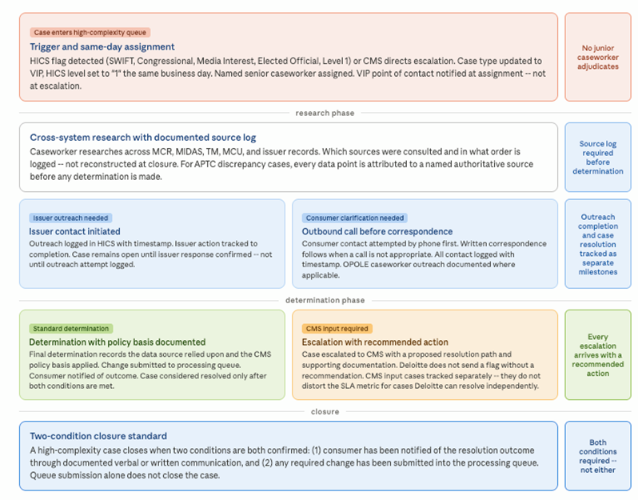
For cases where resolution requires a change to the FFE, the determination does not end at closure — it triggers a controlled submission sequence that protects both the consumer's tax record and the integrity of the correction cycle. Before any retroactive action reaches the FFE, Deloitte will map the full downstream consequence: which correction cycle it falls into, whether a corrected or voided 1095-A will be generated, and the correct submission order for related enrollment segments. Sequencing errors generate new disputes; catching them before submission is less costly than resolving them after. For SBEs, Deloitte will document findings with enough specificity for direct SBE action. Batch corrections and manual overrides will carry supervisory sign-off with a complete time-stamped audit trail before submission.

Tax season surge readiness
Recruitment begins in November and clearance begins at offer acceptance, enabling the first deployment wave to be cleared and trained before January 1. Additional caseworkers are deployed just in time for February and March peak volumes, then released in phases as volumes decline through June. Returner caseworkers skip baseline training and complete only a policy update refresher, reaching full productivity from their first day back. New hires train on the prior year's actual root-cause case types under peer certification by returners before touching live cases. The result is a surge workforce that improves in quality each year rather than repeating the same ramp.

Surge operating standard | Deloitte commitment
QA and supervision | Maintained at base-period standards throughout January–May
Daily aging review | Aging dashboard reviewed each morning; at-risk cases flagged same day
Reserve capacity | Pre-cleared reserve staff activate at defined volume thresholds

Trend identification and process improvement
Deloitte will treat the incoming dispute queue as an early-warning signal rather than a workload to process. The table below shows the specific actions and what each means for CMS's ability to reduce future dispute volume.

What Deloitte will do | What this means for CMS
Review HICS narratives and CERRS attributes daily | Give CMS early visibility into emerging 1095-A dispute patterns
Pull correlated cases and escalate root cause with bulk-action recommendation | Enable CMS to resolve shared-root-cause cases through one coordinated action
Deliver monthly improvement actions by channel | Equip CMS to issue targeted guidance through issuer webinar, email blast, REGTap, or CMSzONE
Share Task 2 and Task 3 data weekly | Help CMS identify issuer-driven consumer disputes earlier
Deploy AI-assisted HICS text analysis, with CMS approval | Help CMS detect emerging dispute trends faster than manual review alone

Quality assurance
QA is Deloitte's mechanism for ensuring the three-lane model performs consistently, not just on average. The table below shows how each QA element translates into a specific outcome for CMS.

Quality assurance element | What it means to CMS
Elevated sampling categories: APTC, retroactive adjustments, override actions | The highest-risk case types are reviewed most frequently -- errors caught before they generate corrected 1095-As, amended returns, or new disputes
Case note review and quality scoring: closed cases reviewed against defined criteria for research sequence, documentation completeness, rationale, and audit-ready closure | CMS has a structured, case-level quality method -- not just spot checks -- confirming that determinations are correct, fully documented, and ready for oversight review
Inconsistencies become training and SOP updates | Inconsistent determinations eliminated systematically, not managed one caseworker at a time
Targeted coaching for recurring errors or low-quality case handling | Caseworkers with repeat documentation or determination issues receive focused corrective coaching before error patterns spread into production
Systemic pattern detection escalated to CMS with root cause and recommended fix | CMS receives a diagnosis and a proposed fix, not a performance report
Emerging issue notification: new error pattern surfaced with documented finding and proposed corrective action | CMS is first to know about a quality risk in the program

Table 1.2.2-1. Three-Lane 1095-A Resolution Model.
Challenge | Deloitte mitigation
Transition risk and Day 1 continuity: lost files, broken SLA clocks, and intake disruption if inherited workflows are not validated quickly | Deloitte validates inherited workflows, reconciles open inventory against CERRS during transition-in, and confirms HICS-to-CERRS intake, classification logic, and reporting before steady-state operations begin.
Tax season volume spikes: volume may triple January through May, threatening service levels if surge planning is not built in ahead of time | Returner-first staffing strategy with recruitment beginning November. All temporary caseworkers cleared and trained before January. QA rigor, aging oversight, and SLA monitoring maintained at base period standards throughout surge.
Complexity-driven SLA risk: low, medium, and high complexity require different research paths and SLA definitions; mis-routing ages cases unnecessarily | Automated case typing at intake with trained caseworker fallout queue for ambiguous cases. Experience-based assignment ensures senior capacity is reserved for complex cases. SLA-excluded exceptions tracked separately with documented reasons.
Retroactive correction sequencing errors: out-of-sequence FFE submissions create new data conflicts that become new disputes | Deloitte maps the full downstream consequence before any retroactive action is submitted: correction cycle, 1095-A impact, and submission sequence confirmed before execution. Sequencing errors caught before submission rather than resolved after.
Recurring disputes driven by upstream root causes: processing cases individually is inefficient when multiple cases share the same origin | Daily monitoring of HICS narratives and CERRS attributes surfaces correlated clusters same-day. Correlated cases escalated to CMS with bulk-processing recommendation and root cause summary rather than worked individually.

Subtask 3.1: Low Complexity 1095-A Disputes ^{(SOW 3.3.1)}

Subtask 3.2: Medium Complexity 1095-A Disputes ^{(SOW 3.3.2)}

Subtask 3.3: High Complexity 1095-A Disputes

1.2.3 Task 4: Complex Case Help Center (CCHC) ^{(SOW 3.4)} (2.5 Pages)
Our Understanding
Consumers referred to the CCHC have already contacted the Call Center, engaged with an issuer or assister, and still could not resolve their coverage situation through standard channels. The cases that arrive here - DMIs, delayed enrollments, retroactive terminations, APTC discrepancies -- sit at the intersection of policy complexity, multi-system data conflicts, and human circumstances that standard processes were not designed to handle. For these consumers, coverage uncertainty is not a data problem. It is a barrier to care and a source of financial stress.
Getting this right requires more than process adherence. It requires caseworkers who arrive trained for the cases they will actually encounter and an escalation discipline that surfaces the right issues to CMS before they become visible problems. CCHC is the only workstream in this contract where the human cost of a process failure is visible in real time.
Beyond case resolution, CCHC serves as a critical feedback mechanism for CMS. Analysis of recurring trends, root causes, and resolution patterns provides visibility into upstream breakdowns across the broader Exchange ecosystem. Monthly casework reveals where cases could have been resolved upstream, where HICS categorization is inconsistent, where policy clarification is needed, where issuer actions diverge from CMS requirements, and where FFE system defects are generating avoidable case volume. Weekly and monthly reporting are not administrative byproducts. They are how CMS prevents the next wave of escalations.
Our Approach
Deloitte will operate CCHC as a live, consumer-facing resolution function from Day 1, staffed by caseworkers who will have completed scenario-based training before any live case is assigned. The approach builds directly on the shared transition-in and weekly cross-task data share described in Section 1B.1, and is organized across three dimensions: steady-state case operations, reporting and program intelligence and capacity management.
Steady-state case operations
Figure X.X-X. Provide Title.
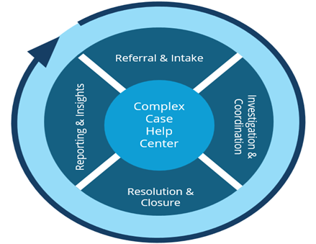
Deloitte will apply a channel-agnostic triage protocol so that case classification is governed by the case type, not by which intake channel referred it. A retroactive termination case referred from the Exchange Call Center will receive the same classification logic, research path, and documentation standard as one referred from OPOLE or CMS leadership. This consistency is what makes QA sampling meaningful: when every caseworker follows the same protocol, deviations are detectable and correctable rather than buried in channel-specific variation.
Unlike Task 2 issuer dispute processing, which resolves data discrepancies reported by issuers, CCHC casework resolves coverage problems often originated by consumers. The five-stage workflow below governs how every CCHC case will move from intake to confirmed closure.
Table 1.2.3-1. Five-Stage CCHC Case Workflow.
Stage | What Deloitte will do and why it matters
Intake and triage | Every case is triaged on four dimensions: issue type, complexity, referral source urgency, CMS prioritization. Channel-agnostic protocol eliminates categorization inconsistency, improving downstream reporting accuracy and enabling reliable root cause analysis.
Assignment | Cases routed based on agent expertise and specialization. Senior agents handle VIP cases (SWIFT, Congressional, Media Interest, Level 1 HICS flags). Specialized queues manage DMIs, delayed enrollment, retroactive terminations, APTC, and difficult-to-enroll populations. A named point of contact will be assigned to every VIP case at intake and will remain accountable through closure, ensuring the consumer has a single, consistent point of contact regardless of how the case was referred or how long resolution takes.
Investigation | Issue-specific checklists and required-evidence prompts will guide caseworkers through a defined research sequence across MCR, TM, MCU, MIDAS, HICS, and SEED. Anomalies will be flagged in the workflow as they arise. Documentation will be captured in real time, not reconstructed at closure, and all communications with issuers and consumers -- including content, channel, and outcome -- will be recorded as they occur, ensuring a complete and auditable case record.
Resolution | CMS-aligned playbooks define resolution steps and policy basis. Resolution outcomes include clear, actionable instructions for each stakeholder (consumer, issuer, assister, agent/broker, FFE update) with accountability established prior to closure. Issuer actions documented and tracked to completion. Escalations include a recommended resolution with supporting documentation - not just issue flagging. Submitted documentation is reviewed for consistency and completeness before any determination proceeds.
Closure | Cases close only when three conditions are met: action completed and confirmed, consumer notified verbally or in writing, and complete metadata captured. Required-field validation is enforced at workflow level.

The five-stage workflow is only as consistent as the caseworkers executing it. No caseworker will handle a live case until completing training and demonstrating readiness against a defined competency threshold. The training curriculum will be built from prior-year CCHC root cause data: caseworkers will be trained on the actual case types and issuer patterns that drove the most volume and complexity in the prior season, not on generic system orientation. This is the same scenario-based approach applied to the Task 3 surge workforce, applied here to the permanent CCHC team. Training will emphasize both technical resolution and consumer-centered handling, equipping caseworkers to resolve complex cases with accuracy, empathy, and clear communication. Returner caseworkers will serve as peer certifiers for new hires. Within the first 90 days, Deloitte will conduct a structured SOP gap assessment and submit recommendations to CMS as a formal deliverable.
QRGs will be reviewed quarterly and updated promptly following any CMS policy change, with updates versioned, distributed, and confirmed as received before caseworkers begin applying new procedures. QA sampling will include integrity-focused review. Unusual resolution patterns, override activity, and inconsistent determinations across similar cases will be flagged for supervisor review. When QA surfaces a pattern, it will become a training scenario and an SOP update, not a quality log entry.
Reporting and program intelligence
CMS does not need a contractor who compiles what happened last month. CMS needs a contractor who shares with CMS what to do about it. Every reporting deliverable under Task 4 closes with specific recommended actions -- drafted, evidence-supported, ready to act on.
Table 1.2.3-2. Reporting Outputs and CMS Actions.
Deliverable | Frequency | Deloitte's commitment beyond the requirement
Operational report | Weekly | Cases flagged by name at SLA risk, not aggregate counts. Escalations include a recommended next step, not just a flag.
Root cause analysis | Monthly | Each finding closes with a drafted CMS action. Issuer pattern communications arrive formatted and ready to distribute, not as a summary requiring further drafting.
Root cause analysis | Quarterly | Multi-month patterns surfaced with a prioritized action agenda for CMS review.
Issuer pattern escalation | Ongoing | Patterns identified at intake through CERRS metadata, not discovered weeks later in reporting. Surfaced to the Task 2 issuer dispute team through the weekly cross-task data share so CMS sees a consistent picture across both workstreams.
Tax season cross-task coordination | Jan through May | APTC cases spanning CCHC and Task 3 resolved through a single workflow with a single consumer point of contact. Issuer non-compliance documented with volume and pattern analysis for targeted CMS action.

Reporting data will be a byproduct of operational execution. CERRS metadata captured at every workflow step will feed EDA CORE dashboards directly, creating a unified live view across Tasks 2, 3, and 4 without separate compilation.
Issuer coordination and cross-task integration
Issuer coordination in CCHC will be pattern-driven, not case-by-case. When the same issuer drives a similar issue across cases, those patterns will be identified at intake through CERRS metadata association, not discovered weeks later in monthly reporting. This is made possible by the same metadata framework that supports issuer analytics in Task 2. Deloitte will surface CCHC-identified issuer patterns to the Task 2 issuer dispute team through the weekly cross-task data share, so CMS sees a consistent picture across both reports. CCHC will coordinate directly with Task 3 during tax season when APTC cases may span both workstreams. Overlapping issues will be resolved through a single workflow with a single consumer point of contact. Issuer non-compliance will be documented, categorized, and reported with volume and pattern analysis enabling CMS to take targeted action.
Capacity management
Deloitte will build the CCHC staffing model around the actual volume curve, not an annual average, applying the same surge readiness principles as Task 3: caseworkers scenario-trained before volume arrives, supervisory ratios maintained at peak, and a defined reserve pool that activates on a threshold rather than requiring a new recruitment cycle. Supervisory ratios, QA coverage, call monitoring standards, and reporting timelines are operational commitments that will hold at peak volume, not targets that degrade when caseload increases. The staffing plan submitted at kickoff will show coverage at each volume scenario, and flex capacity will be drawn through cross-trained reserve staff, temporary reallocation from aligned workstreams, and targeted short-term support as directed by CMS.
Table 1.2.3-3. Capacity and Surge Plan.
Challenge | Deloitte mitigation
Transition risk: CCHC operations rely on informal decision logic that SOPs do not capture -- gaps emerge only after go-live if not captured during transition | TruNorth captures routing rules and escalation dependencies from source code independently. Full production workflow shadowed during transition-in to document informal decision points. Readiness confirmed against a structured runbook before case transfer begins.
Agent readiness: complex eligibility and enrollment scenarios cannot be learned on live consumer cases involving stressed or vulnerable individuals | Scenario-based curriculum built from prior-year root cause data. Agents trained on actual case types before handling live cases. Competency assessed before independent case handling. Returner agents serve as peer certifiers for new hires.
Reporting quality: descriptive monthly reports tell CMS what happened but not what to do about it | Every reporting deliverable closes with specific recommended actions drafted for CMS review. Monthly root cause analysis goes further, closing each analytical category with a prioritized action and supporting evidence. CMS receives a decision package, not a trend summary.
Seasonal volume fluctuation: referral volume peaks during Open Enrollment and tax season, threatening quality and reporting timelines if only headcount is added | Surge model deploys trained headcount, not just headcount. Supervisory ratios, QA coverage, and reporting timelines held constant at all volume levels. Staffing plan shows coverage at each volume scenario, not a single average-volume number.
Issuer non-compliance visibility: issuer patterns that drive CCHC cases may not be visible to issuers or CMS without structured analysis | Issuer coordination is pattern-driven, not case-by-case. Patterns identified at intake through metadata association. Deloitte drafts recommended issuer communications for CMS review and distribution through all-issuer webinars, REGTap, and CMSzONE.

1.2.4 Task 5: Updating the FFE ^{(SOW 3.5)} (0.5 Pages)
Our Understanding
FFE update accuracy is not a Task 5 function in isolation. It is the mechanism by which every dispute resolution in Tasks 2 and 3 actually takes effect. A case closed correctly in CERRS but submitted to the FFE with a sequencing error or a missed pre-validation has not been resolved -- it has created a new data problem that will surface as a downstream dispute or an incorrect 1095-A. Deloitte treats this workstream as a precision execution function: every submission type (standard BUU, non-standard BUU, Hard Case, Update Policy API) governed by the same cycle discipline, every action logged from compilation through confirmed FFE update, and CMS notified of any exception before it becomes a rework cycle.
Our Approach
Deloitte will be operationally ready before the first submission window opens. During transition-in, the pipeline is validated end-to-end against live system behavior -- compilation logic, pre-validation rules, OA Contractor interface, and QA Team handoff -- so there are no surprises in the first correction cycle. Prior-year submission history is reviewed to surface informal compensating controls that are not in current SOPs, and those gaps are formalized before Deloitte takes ownership. The table below shows how Deloitte will manage each submission type, what CMS sees, and what the control is.
Table 1.2.4-1. FFE Submission Pipeline by Type.
Submission type | How Deloitte manages it | What CMS sees
Standard and non-standard BUU | Compiled against each of ~22 Correction Cycles and the monthly Recon Run Calendar. Internal pre-validation completed before any file reaches the OA Contractor. | Cycle-level status dashboard: compiled, validated, submitted, confirmed -- updated after each stage
Hard Case updates | Scheduled into the same correction cycle calendar as standard BUU. Not treated as ad hoc exceptions. | Hard Case volume and disposition tracked in the same weekly report as standard submissions
Update Policy API (Rejected Enrollment, Undetected Overlap) | Pre-validation completed before API submission. Confirmation logged before associated case is closed. | API submission outcomes included in the weekly corrections report
Retroactive adjustments | Downstream consequence mapped before submission: correction cycle, 1095-A impact, segment submission order. Sequencing errors caught at compilation. | Exception report when a submission requires resequencing, with root cause and resolution path

1.2.5 Task 6: Notice Generation ^{(SOW 3.6)} (0.5 Pages)
Our Understanding
Task 6 notices are operational program communications triggered by specific enrollment and reconciliation events, Death Periodic Data Matching alerts, ER&R third failed attempt letters and similar notices that inform consumers of a specific action taken or required in their case. These are not the original 1095-A tax forms. They are the communications that accompany or explain program decisions, and their accuracy, timing, and language compliance matter because consumers act on them.
The work is primarily a pipeline execution and compliance function: merge consumer data into CMS-provided templates, transmit to the Federal Marketplace Print contractor via EFT, upload to DSRS, and confirm delivery. Approximately 40 notices require updating annually, and each must meet statutory multilingual requirements that can change during the contract period. Deloitte will run this as a precision compliance function with full pipeline visibility to CMS at every stage.
Our Approach
Transition-in establishes the baseline: full notice library inventory, translation status by notice and language, current print vendor specifications, and EFT and DSRS configuration -- validated against live system behavior before the first notice file is generated.
In steady-state, Deloitte manages the pipeline through a simple operating discipline: validate before generating, confirm before closing. No notice file is transmitted without a successful EFT confirmation. No batch closes without a confirmed DSRS upload. Every content change triggers a translation review before the updated notice enters production. CMS sees pipeline status through a standing notice generation report covering volume, timing, translation status, and any exceptions -- no surprises, no quiet resolutions.
Table 1.2.5-1. Notice Generation Pipeline Controls.
What Deloitte tracks | Reported to CMS | Escalation trigger
Data merge validation against source records | Pre-generation status per notice type | Missing fields or data anomalies caught before file generation
EFT transmission confirmation | Transmission status and timestamp per batch | Failure triggers same-day CMS notification and remediation path
DSRS upload confirmation | Upload completion and file count per batch | Failure triggers immediate remediation before batch is closed
Translation currency per notice and language | Translation status in standing notice report | Content change without confirmed translation update escalated before production
508 compliance per notice update | Compliance confirmation per design change | Design-stage failure escalated before the notice enters the production queue

Table 1.2.5-2. Task 6 Challenges and Mitigations.
Challenge | Deloitte mitigation
Translation dependencies are not always triggered when English content changes, creating out-of-sync translated notices that may not surface until a consumer complaint | Translation update trigger built into the notice change workflow. Every content change initiates a translation review before production. Translated notices confirmed accurate before EFT transmission.
Print vendor specification mismatches discovered at transmission cause rework and delay consumer delivery | Transition-in pipeline audit validates current print specifications and identifies pending spec changes before Deloitte generates its first notice. Spec changes managed through a documented workflow before production.
Approximately 40 annual notice updates create compression risk when multiple notices update simultaneously near a filing deadline | Annual update schedule tracked against Correction Cycle and consumer filing deadlines from contract start. Updates sequenced to avoid compression near high-impact windows.
DSRS upload failures may not be discovered until a consumer or issuer attempts to retrieve a notice | DSRS upload confirmation logged per notice file before batch closes. Failures trigger immediate remediation, not next-day discovery.

During CA SBM take over, we took over the notice generation from the incumbent’s print vendor to a high volume print vendor Deloitte chose. We were able to migrate the inbound documents and outbound notices interfaces, processes and controls in-flight seamlessly.

1.2.6 Task 7: Telephone and Correspondence Support ^{(SOW 3.7)} (2 Pages)
Our Understanding
Task 7 is the connected front door for stakeholder engagement across ER&R — not a generic contact center. It supports consumers seeking 1095-A and complex case help, issuers managing dispute and reconciliation activity, FFE and SBE staff coordinating casework, and employers responding to FFE notices. The work is multi-channel by design: inbound calls, outbound calls, voicemail, issuer email through the ER&R Support Center and Enrollment Community, and written correspondence triggered by enrollment and reconciliation events. Done well, every interaction advances a single case toward resolution, contributes to one auditable case history in CERRS, and produces operational signal that helps CMS identify scripts to refine, training to deliver, and upstream issues to address. Done poorly, channels operate as silos, voicemails age past the one-business-day standard, scripts drift from CMS-approved versions, and stakeholder trust erodes. Deloitte will operate Task 7 as the integrated hub the SOW envisions, with closed-loop visibility, embedded program-integrity controls, and a continuous improvement engine that converts contact trends into approved process changes.
Our Approach
Deloitte will run Task 7 through a single integrated stakeholder-support operating model with five dimensions. (1) Stakeholder-aware triage: every contact is classified at intake by stakeholder type (consumer, issuer, FFE/CMS staff, SBE/state, employer) and case type, then routed to the lane with the right SOPs, scripts, and subject matter expertise — not just to the next available agent. (2) Closed-loop case visibility: every call, voicemail, issuer email, and correspondence touch is logged in CERRS or the appropriate CMS case system, with the same case ID linking interactions across channels so the next contact never starts cold. (3) SLA-governed channels: Monday–Friday 8 AM–8 PM ET inbound coverage; voicemail response within one business day per SOW §3.7; issuer email response measured against COR-approved targets; and correspondence handled through the CMS-provided system on a tracked workflow with documented decision points. (4) Issuer-support lane: a dedicated ER&R Support Center workflow with all issuer communications documented in Enrollment Community, mass issuer communications coordinated through approved CMS channels, and structured testing and feedback support for Enrollment Data Alignment enhancements. (5) Outbound as a resolution lever: outbound calls are used proactively when live contact will close a case faster than written exchanges — particularly for unauthorized enrollment outreach, 1095-A consumer disputes requiring clarification, and pre-deadline issuer coordination.
Quality, compliance, and program integrity are operating obligations rather than periodic audits. Every agent works against CMS-approved scripts and SOPs; script changes flow through the COR before deployment; QA samples calls and correspondence weekly with elevated sampling for sensitive case types (APTC discrepancies, retroactive terminations, Death PDM contacts); training refresh is delivered within the same cycle as any policy or system change. Workforce management forecasts demand against the SOW Task 7 monthly volume table (CCHC, 1095-A, and ER&R inbound/outbound calls; CCHC and ER&R email volumes), aligns staffing to seasonal patterns, and maintains supervisory ratios at peak. AI-assisted triage — voicemail transcription and categorization, intent classification on inbound calls — is introduced only with COR approval and operates strictly with human oversight; no automated decision affects case outcome without agent confirmation.
Continuous improvement is built into the model rather than reported quarterly. Recurring caller themes, repeat issuer questions, and escalation patterns are surfaced to CMS as actionable feedback in the monthly Form 1095-A Consumer Disputes and Enrollment Process Improvement Report, with proposed script updates, SOP revisions, and upstream system or process recommendations. Trend findings flow into the cross-task data share described in Section 1B so a pattern visible in CCHC calls becomes a Task 2 dispute analytics input or a Task 3 surge-training topic, not an isolated observation.
Proof Points
- Covered California Health Insurance Exchange Contact Center. Deloitte stood up Amazon Connect in approximately 40 hours during annual Open Enrollment when contact volume peaks near 300,000 contacts per month. Deloitte provided project management, engineering, testing, training, and hypercare; led go-live and SSO migration with zero critical or high-impact issues; and continues to support enhancements including courtesy callback, post-call survey, conversational IVR, custom agent desktop, and advanced reporting — directly relevant to digital exchange support, continuity under load, and contact-center modernization for ER&R Task 7.
- FinCEN Beneficial Ownership Contact Center. Deloitte stood up and operates a federal compliance-oriented contact center on Salesforce Government Cloud Plus, Amazon Connect, and AWS Lex in a FedRAMP High environment. The team eliminated a 5,000-case backlog within three months, closed 350,000+ cases, conducted 23,000+ outbound calls, and audited 11,000+ cases at an average QA score of 96% — directly relevant to Deloitte's ability to operate federal case-management operations with disciplined QA, dashboard-driven performance management, and outbound resolution as a Task 7 lever.
- U.S. Navy MyNavy Career Center (MNCC). Deloitte redesigned and operates a tiered omnichannel HR service-delivery model supporting 330,000+ Sailors with Salesforce CRM, Cisco telephony, IVR, post-call survey, command center, WFM, QA, and reporting and analytics. The model handles 36,000+ contacts per month and has supported 1.5 million customer requests since launch — directly relevant to Task 7 federal omnichannel operating-model design, command-center integration, contact-driver analysis, and knowledge management.

1.2.7 Task 8: IT Systems ^{(SOW 3.8)} (5 Pages)
Our Understanding
The ER&R technology environment spans four core systems, CERRS, SEED, HICS, and EDA CORE, all operating within the CMS Microsoft Azure Government (MAG) cloud enclave. These systems connect through a layer of APIs, data pipelines, security controls, and infrastructure services that must function reliably together. A change to one system has consequences across the others.
Figure 1.2.7-1. [Deloitte to populate: figure title and graphic].
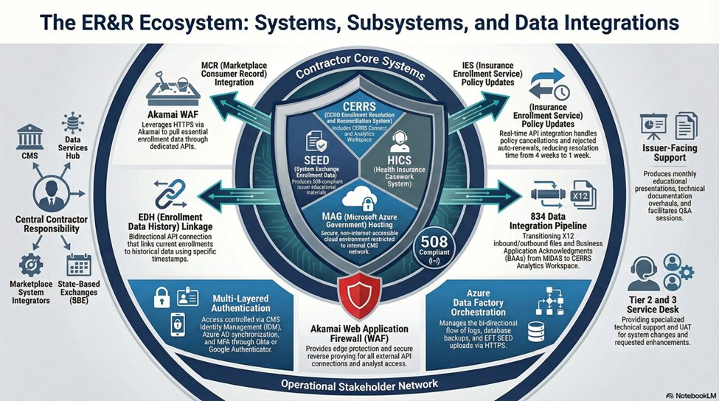

All external API traffic routes through an Akamai Web Application Firewall before reaching the MAG environment. Azure Data Factory manages bidirectional log, backup, and file transfer orchestration. The 834 X12 data integration pipeline processes thousands of transactions per hour during Open Enrollment. Access across all systems is governed by CMS Identity Management, Azure AD synchronization, and multi-factor authentication through Okta Authenticator. Each of these dependencies must be maintained, monitored, and validated across every release cycle.
Sustaining this environment requires a delivery model capable of governing operations, planned change, and cross-program coordination simultaneously without disruption to live casework. That is the baseline. Deloitte's approach is built to deliver that baseline from day one and then go further.
Our Approach
CMS deserves a contractor that does more than keep the lights on. Deloitte is that contractor. Deloitte's approach to Task 8 is designed to operate this environment reliably and securely from day one and systematically raise the bar from there. Our approach is structured around two objectives. The first is operational: assume responsibility without disruption, govern the live environment with discipline, protect mission-critical infrastructure and sensitive data in full alignment with CMS security and privacy requirements, and build the confidence that comes from consistent, reliable delivery. The second is transformational: once that foundation is established, apply AI-enabled automation to reduce manual effort across technology and business operations, simplify how staff, issuers, and consumers interact with the environment, and create a credible path to long-term architectural consolidation.
These two objectives are not sequential in a strict sense. Operations and improvement run in parallel. Each phase builds on the one before it and delivers value before the next begins in full.
Figure 1.2.7-2. [Deloitte to populate: figure title and graphic].
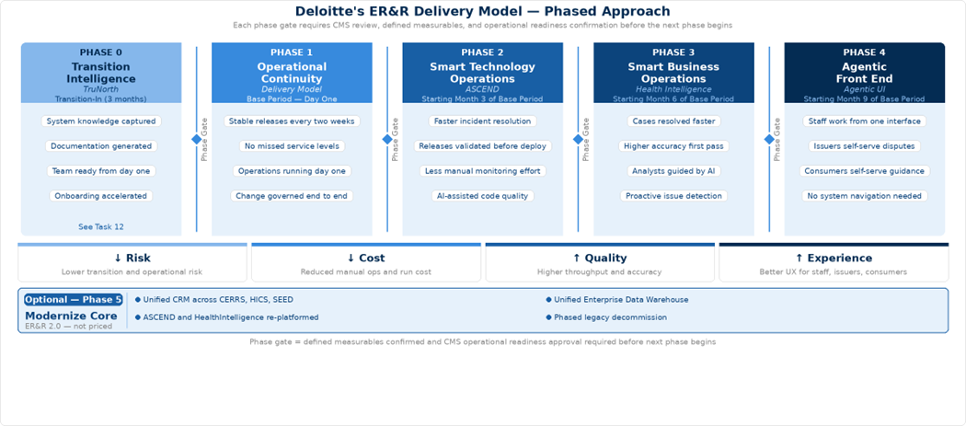

Phase 0, Transition Intelligence, is addressed under Task 12. Phase 1 delivers the operational objective. Phases 2 through 4 deliver the transformational objective, each building on the foundation Phase 0 and 1 establishes. Phase 5, Modernize Core, is a future-state direction that is not proposed or priced as part of this bid.
Phase 1: Operational Continuity
Operational Continuity — Assuming Responsibility Without Disruption
Deloitte will staff two dedicated teams under Task 8. The Operations and Maintenance team owns production stability: incident response, after-hours data loads, ingestion monitoring, service desk support, and the daily operational continuity of CERRS, SEED, HICS, and EDA CORE. The Enhancement and Modernization team owns planned change: bi-weekly releases, quarterly rule updates, annual form changes, code modernization, and CMS-prioritized improvements. Both teams operate under one integrated delivery framework, so work is coordinated, not siloed.
Maintaining stability while introducing change is the central operational challenge in this environment. What makes this model effective is not the separation itself but the discipline at the boundary between the two teams. Nothing moves from Enhancement into Operations without a validated cross-system impact assessment, release readiness review, and rollback plan in place. That handoff, governed through shared intake, a coordinated release calendar, and dependency review across CERRS, SEED, HICS, and EDA CORE, is where system stability is preserved as the environment continuously evolves.
From day one, Deloitte manages the following recurring obligations across all systems:
- Bi-weekly sprint releases and Change Control Board coordination across CERRS, MCR, SEED, HICS, and EDA CORE
- SAFE Agile PI Planning participation quarterly
- TRB preparation, presentation, and findings remediation
- After-hours data loads, file ingestion monitoring, data remediation, cleansing, and file scanning
- Annual Enrollment Dispute Form updates and quarterly issuer dispute rule updates
- Annual documentation suite updates — ICD, DDD, SDD, RTM, Testing SOP
- CMS governance activities — penetration testing, ACT assessments, IV&V support, FedRAMP sponsorship for Snowflake
- 508 compliance across all system documentation, issuer materials, and presentations
Table 1.2.7-1. AIOps Capabilities Across All Systems.
Capability | What Deloitte Delivers | Benefit to CMS
Integrated Delivery Model | Two dedicated teams: Operations and Maintenance, and Enhancement and Modernization, both governed through shared intake and a single release framework. | Both teams operate without competing for the same priorities or capacity.
Shared Intake and Prioritization | Single intake path for incidents, recurring updates, and approved enhancements across CERRS, SEED, HICS, and EDA CORE | CMS has one visible queue for all Task 8 work; priorities are set once and honored across both teams
Coordinated Release Management | Integrated release calendar with cross-system dependency review before every deployment | No release is approved without a validated view of downstream effects across all four systems and their interfaces
Documentation Embedded in Delivery | Runbooks, SOPs, and system documentation updated within the same release cycle that changes the behavior they describe | Service desk staff and caseworkers always work from documentation that reflects the live environment
Recurring Manual Operation Reduction | Repeat manual activities identified and reduced through standardized procedures, automated alerting, and targeted engineering fixes | Operational labor cost decreases over the contract period as manual steps are replaced with governed automation

1.2.7.1 CERRS — CCIIO Enrollment Resolution and Reconciliation System
Microsoft Dynamics CRM | Azure Government | .NET | Custom APIs
CERRS is the Microsoft Dynamics CRM-based platform that serves as the central technical backbone for issuer disputes, Form 1095-A consumer disputes, and CCHC casework. It is the primary integration point for inbound source data from HICS, MIDAS, and other Exchange systems, and the origin of downstream updates to the FFE. Beyond the program-wide obligations covered in Phase 1, Deloitte will specifically deliver for CERRS: 24/7 outage support; annual Enrollment Dispute Form updates and quarterly issuer dispute rule updates; after-hours data loads, ingestion monitoring, and data remediation; code base modernization to Azure cloud services; CRM optimization; Power BI migration; and disaster recovery and business continuity planning.
How Deloitte Will Operate CERRS
Deloitte will manage CERRS daily through platform monitoring, integration health, deployment discipline, and security operations, each running concurrently as standing obligations.
Plugin execution logs will be reviewed daily for synchronous failures that block casework transactions in real time, asynchronous backlogs that delay case status updates, and workflow errors that stall dispute routing. CRM job queues will be actively managed against defined thresholds, so queue saturation is addressed before it affects casework throughput. Integration monitoring will cover the CERRS Connect interfaces to HICS, MIDAS, MCR, and the FFE with transaction logs reviewed daily for failed records, mapping errors, and timeout patterns. After-hours data loads will run against defined monitoring ownership, automated failure alerts, and documented escalation procedures so a failed load is identified, and recovery initiated within minutes, not at the start of the next business day.
Every CERRS release will follow managed solution discipline: customizations contained in properly structured solutions with publisher prefix controls, changes promoted through DEV, TEST, and PROD with configuration data migration handled separately from solution deployment, and rollback plans prepared before production deployment. Dynamics storage quotas and API rate limits will be monitored proactively because breaching either causes platform-wide impact, particularly during the concurrent high-volume periods of Open Enrollment and Form 1095-A season.
Security operations will be maintained continuously. Role-based security profiles, field-level security for PII-containing casework fields, and team memberships will be updated as staff changes occur and as temporary analysts onboard during Form 1095-A ramps. Audit log compliance for sensitive fields will be a standing obligation, not a periodic review.

1.2.7.1.1 MCR — Marketplace Consumer Record
Deloitte will operate the MCR integration as a governed dependency within the CERRS release and monitoring framework. Daily monitoring will cover API response times, error rates, and timeout patterns across the consumer and enrollment data calls CERRS makes to support dispute research and casework resolution. Data mapping between MCR and CERRS will be maintained as a versioned artifact updated whenever either system changes, with integration regression tests validating field-level mapping accuracy, not just successful API responses, as part of every release cycle. As an MCR Data Contributor, Deloitte will govern consumer action and interaction data written back into MCR with automated confirmation monitoring, so contribution failures are detected before gaps accumulate and affect downstream case research.

3.8.1.2 SEED — System of Exchange Enrollment Data
.NET Application | CMS Enterprise Portal | Issuer-Facing | Real-Time FFE Data
SEED is the issuer-facing .NET portal hosted on the CMS Enterprise Portal that provides real-time FFE enrollment data access and supports dispute submission, prior-year dispute handling, post-deadline inaccuracy requests, and related approval workflows. Beyond the program-wide obligations covered in Phase 1, Deloitte will specifically deliver for SEED: four issuer-facing slide presentations per month; two half-hour interactive issuer sessions with live Q&A monthly; monthly CMS/SEED coordination meetings; quarterly improvement recommendations; two comprehensive technical documentation overhauls per year; approver and user administration including submitting approver requests to CMS and maintaining issuer rosters; outage notification; performance monitoring; and release coordination.
How Deloitte Will Operate SEED
Deloitte will operate SEED across three concurrent responsibilities: application operations, issuer engagement delivery, and approver and user administration.
On the application side, Deloitte will monitor SEED performance daily including portal response times, dispute submission success rates, API call volumes to the Enrollment Modernization APIs, and error patterns in the real-time FFE data retrieval layer. Submission path behavior will be validated against underlying API contracts before each release, specifically targeting dispute submission, status display, and approval workflow surfaces where misalignment generates the highest volume of issuer support demand. Release coordination will follow the same managed solution discipline applied across CERRS, with changes moving through DEV, TEST, and PROD and outage notifications issued to CMS and issuers in advance of any planned downtime.
Issuer engagement will be managed as a standing delivery commitment with defined ownership, not as an ad hoc activity. The four monthly slide presentations, two live issuer sessions with Q&A, monthly CMS coordination meetings, and quarterly improvement recommendations will each have a designated owner, a preparation timeline, and a delivery standard. Issuer feedback captured through sessions and Q&A will be documented and fed into the quarterly improvement recommendation cycle so CMS receives a structured view of issuer priorities rather than anecdotal input.
Approver and user administration will be governed through a defined workflow with turnaround standards for each step. Issuer approver requests will be submitted to CMS within a defined timeframe of receipt, roster reconciliation will be performed on a regular cycle to identify and address access discrepancies, and offboarding will be completed promptly when issuer staff changes are reported. Administration will not be treated as a background task competing for engineering bandwidth.

1.2.7.2 HICS — Health Insurance Casework System
Custom .NET | Azure Government | Casework Routing | Stakeholder Integration
HICS is the official tracking system for Exchange casework — the intake and routing layer through which the FFE Call Center and other stakeholders route cases requiring investigation and resolution before they reach CERRS. Beyond the program-wide obligations covered in Phase 1, Deloitte will specifically deliver for HICS: Tier 1, 2, and 3 service desk support; bug fixes and technical debt reduction; data integrations with NGD, NDW, MIDAS, EDL, EDA, SERCO, and CERRS; CCB coordination specific to HICS stakeholders; performance monitoring; outage notification; and disaster recovery and business continuity planning.
How Deloitte Will Operate HICS
Deloitte will operate HICS with particular focus on routing integrity, release validation, and service desk consistency — the three areas where HICS operational failures have the most direct downstream consequences for casework SLA performance.
Routing and queue health will be monitored daily. Deloitte will track case assignment accuracy, queue aging, and handoff completion rates across all active routing paths to identify misrouted cases, stalled queues, and failed CERRS handoffs before they age beyond SLA thresholds. When routing anomalies are detected, Deloitte will trace them to their origin — whether a routing rule, a status transition, a field value, or an integration failure with MIDAS, NGD, or CERRS — and remediate at the source rather than manually reassigning affected cases as a workaround.
Release validation for HICS will be more rigorous than for systems where errors are more easily contained. Because a routing rule change or intake field modification can silently misroute cases across all active queues, Deloitte will maintain regression test coverage mapped to every active routing path and handoff condition. No change affecting intake logic, queue configuration, or the CERRS handoff interface will be promoted to production without that coverage validated and signed off.
Service desk operations across Tier 1, 2, and 3 will be governed through defined resolution timeframes, documented escalation criteria, and runbooks that are updated within the same release cycle that changes the HICS behavior they describe. Deloitte will track first contact resolution rates and escalation patterns by issue type so that recurring service desk issues are identified as candidates for permanent engineering fixes rather than repeated manual handling.

1.2.7.3 EDA CORE — Enrollment Data Alignment CERRS Operations Reporting Environment
Snowflake | Azure Government | 834 Ingestion | Analytics | FedRAMP
EDA CORE is the Snowflake-based central analytics repository that ingests high-volume 834 transaction data and provides the shared reporting foundation for issuer performance, enrollment alignment, and payment analytics across the ER&R program. Beyond the program-wide obligations covered in Phase 1, Deloitte will specifically deliver for EDA Core: high-volume 834 data ingestion daily including thousands of transactions per hour during Open Enrollment; monthly EAPS reporting to issuers and CMS stakeholders; Account Manager Dashboard development and maintenance; payment anomaly, enrollment alignment, and dispute processing reports updated monthly; Tier 2 and 3 service desk support; Snowflake performance tuning and SQL query optimization; UAT facilitation; dataset maintenance and onboarding; and FedRAMP sponsorship for the Azure Government Snowflake deployment.
How Deloitte Will Operate EDA Core
Deloitte will operate EDA CORE across pipeline operations, data quality management, reporting delivery, and Snowflake platform administration as concurrent standing obligations.
The 834 ingestion pipeline operations will be governed through automated job monitoring with defined failure detection thresholds, alerting, and escalation procedures for every scheduled load. During Open Enrollment when pipeline volumes reach thousands of transactions per hour, Deloitte will maintain heightened monitoring coverage with pre-positioned escalation contacts and documented recovery procedures for the most likely failure scenarios. Pipeline failures will be triaged to root cause — whether a source file format issue, a transformation logic error, a Snowflake loading failure, or an upstream MIDAS extraction problem — so remediation targets the origin rather than reprocessing data without understanding why it failed.
Data quality will be managed through validation rules applied at ingestion that check 834 transaction completeness, field conformance, and referential integrity before data enters the EDA CORE transformation layer. Records failing validation will be quarantined, logged, and reported to CMS rather than silently dropped or passed through with errors. Deloitte will maintain data lineage documentation from source 834 file through each transformation step to every reporting output so that when a metric in an EAPS report or Account Manager Dashboard is questioned, the answer can be traced and provided quickly without manual reconstruction.
Reporting delivery will be managed against defined production schedules. Monthly EAPS reports, Account Manager Dashboard updates, payment anomaly reports, and dispute processing reports will each have an owner, a production timeline, a quality review step, and a defined distribution process. Deloitte will maintain a shared metric definition library across all EDA CORE reporting outputs so that the same underlying data produces consistent results regardless of which report surface a stakeholder is viewing.
Snowflake platform administration will include continuous query performance monitoring, storage management, and warehouse sizing reviews conducted on a regular cycle. Deloitte will identify and address query performance degradation before it affects reporting response times, manage Snowflake credit consumption against defined thresholds, and coordinate the FedRAMP sponsorship obligations for the Azure Government Snowflake deployment as a standing governance responsibility.
Phase 2: Smart Technology Operations
Smart Technology Operations — ASCEND Agentic AI Platform
Once the current environment is operating under a controlled delivery model, Deloitte will systematically reduce the manual effort, reactive posture, and technical fragility that characterize complex multi-system environments over time. We apply ASCEND — Deloitte's proprietary Agentic AI platform for technology maintenance, operations, and software delivery — progressively across CERRS, HICS, SEED, and EDA CORE as a governed, human-supervised improvement layer.
ASCEND is a library of purpose-built AI agents organized across two capability domains: Intelligent Operations and SDLC Acceleration. Deployment begins with passive observation and AI-assisted diagnostics, then expands into guided automation and enhancement support as operational evidence accumulates. All agent actions operate under human oversight with defined approval gates.
Table X.X-X. Intelligent Operations — AIOps Across All Systems.
Capability | What Deloitte Delivers | Benefit to CMS
ITSM Incident Management | Unified Level 1 and Level 2 incident classification, triaging, and routing across CERRS, HICS, SEED, and EDA CORE service desk operations. Context-aware resolution recommendations drawn from historical tickets, knowledge base articles, and system-specific SOPs with human-in-the-loop review. | Mean Time to Resolution (MTTR) improves by 60% across CERRS casework disruptions and HICS routing issues. Escalation rates drop 20-30% as service desk staff resolve known patterns without escalation. Staff productivity increases 40-60% across Tier 1, 2, and 3 handling of CERRS, HICS, and EDA CORE incidents.
Root Cause Analysis and Issue Detection | Event-driven automated log analysis and multi-agent diagnostic workflows across CMS MAG applications, correlating signals across CERRS plug-ins, HICS queues, SEED API interfaces, and EDA CORE pipelines. Integrates with Azure Monitor and Application Insights. | Root Cause Analysis (RCA) time is reduced by 70% for production failures that currently require manual log traversal across CERRS, HICS, and EDA CORE layers. Consistent data-driven analysis reduces repeat incidents across all systems.
Intelligent Alert Management | Monitors alert volume across all systems and suppresses low-priority and duplicate notifications during maintenance windows, so operations teams focus only on alerts that require action. Frequency-based escalation ensures recurring anomalies across CERRS, HICS, SEED, and EDA CORE reach the right team without delay. | Alert volume is reduced by 60% so operations staff are not overwhelmed by notifications that do not require action. Critical incident detection improves by 70% for CERRS after-hours failures and EDA CORE ingestion anomalies. Response time to high-priority alerts improves by 50% across all systems.
Batch Job and Pipeline Monitoring | Near real-time detection of CERRS after-hours data load failures and EDA CORE 834 ingestion job failures. Automated RCA using a knowledge base of historical incidents and runbooks. Engineer-approved remediation execution. | Detection and remediation of CERRS data load failures and EDA CORE 834 ingestion failures improves by 70%. Continuous Known Error Database (KEDB) updates mean repeat failures across both systems are resolved faster with each occurrence.
Change Impact Assessment | AI-powered analysis of change requests across CERRS, SEED, HICS, and EDA CORE, extracting impacted systems, interface dependencies, and downstream effects before each bi-weekly release. Automated routing and effort estimation. | Change request processing time is reduced by 85% across the bi-weekly release cycle. Impact assessment accuracy of 90% ensures CERRS plug-in changes, SEED API updates, and EDA CORE pipeline modifications are validated against downstream dependencies before production deployment.

Table X.X-X. SDLC Acceleration — AI-Assisted Development and Maintenance.
Capability | What Deloitte Delivers | Benefit to CMS
Developer Assistant and Code Quality | Developer Assistant agents integrated with CERRS, HICS, SEED, and EDA CORE code repositories and Continuous Integration/Continuous Delivery (CI/CD) pipelines. Automated code quality review, security vulnerability scanning, and unit and integration test generation for every code submission across all four systems. | Code quality issues and security vulnerabilities are identified before they reach production across CERRS, HICS, SEED, and EDA CORE. Developers spend less time on manual review and more time on engineering work that requires human judgment.
Automated Bug Remediation | For identified low-risk production bugs across CERRS, HICS, SEED, and EDA CORE, agents perform Root Cause Analysis (RCA), generate a code fix, and submit for developer review and approval. Proactive dependency scanning identifies outdated or vulnerable libraries with auto-generated update tickets. | Routine bug remediation cycle time is reduced by 60% across all systems. Dependency vulnerabilities in CERRS plug-ins, HICS integrations, and EDA CORE pipelines are identified and addressed before they become production incidents.
AI-Assisted Enhancement Delivery | For bounded CMS-prioritized enhancements across CERRS, SEED, HICS, and EDA CORE, agents take a technical specification, generate code, produce tests, update documentation, and package for deployment under senior developer supervision and approval. | Enhancement delivery cycle time is reduced by 50% from approved requirement to production deployment. CMS-prioritized improvements move through the Software Development Life Cycle (SDLC) faster without reducing governance or quality controls.
Sprint Planning and Estimation | Automated effort estimation with complexity classification, user story generation with acceptance criteria, and capacity-aware sprint distribution applied to the ER&R bi-weekly release calendar across all systems. | Sprint estimation time is reduced by 60% across the bi-weekly release cycle. Sprint planning accuracy improves by 85% so delivery commitments across CERRS, SEED, HICS, and EDA CORE are more predictable and reliable for CMS.
Documentation and Knowledge Currency | Agents generate and refresh technical documentation, dependency maps, runbooks, and support artifacts from code changes, configurations, and ticket resolution patterns across all systems, synchronized with every release cycle. | Technical documentation across CERRS, HICS, SEED, and EDA CORE stays aligned with what is running in production. Onboarding time for new staff is reduced, and service desk staff always work from current guidance rather than documentation that predates the last release.

Phase 3: Smart Business Operations
Smart Business Operations — Health Intelligence Agentic AI Platform
HealthIntelligence is Deloitte's purpose-built operational intelligence platform designed for policy-heavy, judgment-intensive environments. It combines CMS-approved SOPs, business rules, approved playbooks, and case-specific data to help analysts work faster and more consistently while preserving human accountability for every final decision and action.
Deployed as a governed intelligence layer across CERRS, HICS, SEED, and EDA CORE, HealthIntelligence will help analysts assemble cross-system case context, navigate approved resolution playbooks, and produce audit-traceable outputs without manually traversing multiple systems. All outputs are traceable to source policy, approved procedures, and case-specific facts, making every recommendation explainable and auditable for CMS oversight and contractor performance review.
The full application of HealthIntelligence across issuer disputes, Form 1095-A consumer disputes, CCHC, notice generation, telephone and correspondence support, and quality assurance is addressed in Tasks 2 through 9.
Phase 4: Agentic Front End
Agentic Front End — Unified Role-Aware Interface
Today, a case worker navigates two systems to assemble the context needed to resolve a single dispute. An issuer searches across multiple screens to track down an enrollment discrepancy such as an incorrect coverage start date. A consumer calls the FFE Call Center for guidance they should be able to access themselves. Phase 4 changes that. Deloitte will introduce a unified, role-aware conversational interface that gives every user a single point of interaction with the ER&R environment. Staff, issuers, and consumers engage through natural language. The interface resolves their role and intent in the background, surfaces only what they are authorized to see, and connects them directly to the workflows, case context, and guidance they need.
Figure 1.2.7-3. [Deloitte to populate: figure title and graphic].
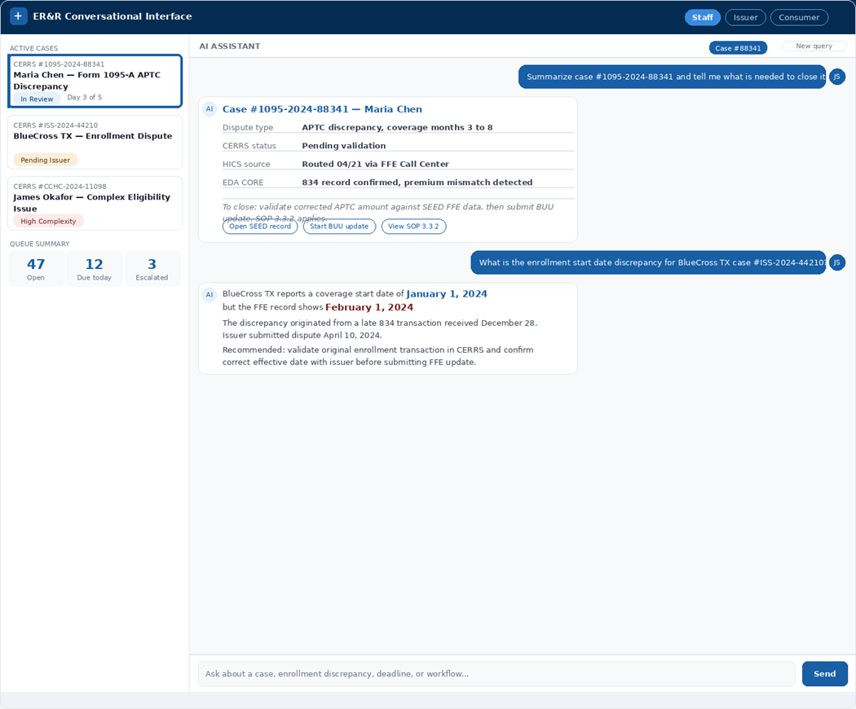

The interface will be introduced in three progressive stages. Each stage is validated before the next is extended.
Table 1.2.7-2. AI-Assisted Development Capabilities.
Stage | User Experience and Outcome
Stage 1 - Internal Command Center | Staff use natural language: "Get a summary of case #12345," "Start a new Form 1095-A dispute," "What is the status of the monthly issuer reconciliation file?" The interface surfaces direct answers and workflow options immediately. Outcome: faster staff execution, reduced training time, and consistent process execution without navigating multiple systems.
Stage 2 - Issuer Self-Service Portal | Issuers interact conversationally: "Submit a new enrollment data dispute," "Check the status of my dispute file," "When is the next data submission deadline?" A simpler alternative to SEED portal navigation for common tasks. Outcome: improved issuer satisfaction and reduced inbound support demand.
Stage 3 - Consumer Self-Service Hub | Consumers receive plain-language guidance: "I need to correct my Form 1095-A," "Why did I receive this notice?" For authenticated users, the interface initiates casework directly. Outcome: consumers resolve common Form 1095-A questions without calling the CCHC, avoidable inbound contacts decrease, and caseworker capacity is preserved for complex cases.

Role-based access controls and security boundaries will be confirmed at each rollout decision point. Prompts, workflow triggers, and knowledge retrieval will be refined through internal use before external users are introduced. This staged approach ensures CMS realizes user experience benefits in a controlled way without introducing operational or security risk.
Phase 5: Modernize Core
Modernize Core — ER&R 2.0 Future-State Vision (Not Proposed or Priced)
Running four systems reliably is not the same as running them efficiently over the long term. Phases 1 through 4 make the ER&R environment more stable, more intelligent, and easier to use. They do not reduce the underlying complexity of maintaining four separate platforms, four separate security footprints, and a growing integration surface across CERRS, HICS, SEED, and EDA CORE. That complexity does not become a crisis but it does become a cost — in maintenance labor, upgrade cycles, and the coordination overhead that comes with every release touching multiple interdependent systems.
Phase 5 addresses that cost by pursuing a deliberate, long-term consolidation of the ER&R architecture into a more unified and sustainable core. Under this vision, functions currently distributed across CERRS, HICS, SEED, and EDA CORE would be rationalized into two modern platforms: a Unified CRM for casework, workflow, and user interaction, and a Unified Enterprise Data Warehouse for shared data, reporting, and analytics. Critically, ASCEND, HealthIntelligence, and the conversational interface do not get rebuilt — they re-platform onto the new architecture and continue operating without interruption, protecting every investment made in earlier phases.
Phase 5 is a recommended future-state direction. It is not proposed or priced as part of this bid. Deloitte raises it because the work delivered in Phases 1 through 4 naturally builds the foundation for it. Better documentation, cleaner integrations, governed data models, and a more traceable environment do not just make today's operations stronger. They make future consolidation a realistic option rather than a risky undertaking. CMS does not need to make that decision now. When the time is right, the groundwork will already be in place.
Table X.X-X. Challenges and Mitigations.
Challenge | Mitigation
Transition knowledge risk: Critical operational knowledge for CERRS, HICS, SEED, and EDA CORE is concentrated in a small number of incumbent subject matter experts. Gaps in knowledge transfer create risk of production disruption during takeover. | Phase 0 Transition Intelligence deploys TruNorth during transition-in to systematically capture system architecture, business rules, workflows, and operational dependencies directly from source code and configurations. The incoming team begins full operations with a validated knowledge base rather than relying on individual incumbents.
Concurrent delivery demands: Bi-weekly releases, after-hours data loads, quarterly rule updates, annual form changes, and CMS-prioritized enhancements must advance simultaneously without production disruption across four interdependent systems. | The two-lane delivery model separates Operations and Maintenance from Enhancement and Modernization so urgent production issues do not displace scheduled releases and planned change does not crowd out daily operational response. Shared intake and a coordinated release calendar govern all work across both lanes.
Cross-system change impact: A change to CERRS plug-ins, SEED API contracts, HICS routing logic, or EDA CORE transformation pipelines can create cascading downstream effects across interfaces that are difficult to anticipate manually. | Phase 2 ASCEND change impact assessment agents analyze upstream and downstream dependencies across all four systems before every bi-weekly release. No change reaches production without a validated view of its effects across system boundaries.
Peak volume readiness: The 834 ingestion pipeline must sustain thousands of transactions per hour during Open Enrollment. Form 1095-A casework triples January through May. Both peaks arrive at fixed, predictable schedules. | EDA CORE infrastructure will be pre-scaled ahead of Open Enrollment. Staffing ramp plans for 100 to 120 temporary Form 1095-A case analysts will be initiated with sufficient lead time to complete onboarding and security requirements before peak volume arrives. Phase 3 HealthIntelligence triage agents will reduce manual processing burden during peak periods.
Documentation: Technical documentation across four systems risks falling out of alignment with production behavior as the environment evolves across multiple release cycles. | Documentation updates will be embedded in every release cycle as a standing delivery requirement. Phase 2 ASCEND documentation agents will auto-refresh technical artifacts from code changes and ticket resolution patterns so that runbooks, SOPs, and system documentation always reflect the live environment.
Security and compliance continuity: FedRAMP, FISMA, HIPAA, PII, and Federal Tax Information protections, 508 compliance, and FedRAMP sponsorship for the Snowflake deployment must be maintained continuously across a CMS MAG cloud environment handling sensitive data. | A dedicated Security and Privacy Officer with Certified Information Systems Security Professional certification will maintain oversight across all systems. Security scanning, Plan of Action and Milestones management, and 508 compliance reviews will be integrated into the standard Software Development Life Cycle as standing obligations rather than periodic events.
EDA CORE ingestion reliability: 834 pipeline failures during Open Enrollment have immediate downstream consequences for reconciliation processing, dispute resolution, and payment accuracy. | Automated job monitoring with defined failure detection thresholds, alerting, and escalation procedures will be in place before Open Enrollment begins. Recovery procedures will be documented and tested so that pipeline failures are remediated within minutes through a governed process rather than an unstructured overnight response.

Proof Points
[To be completed with relevant Deloitte past performance references demonstrating: Microsoft Dynamics CRM development and operations at federal scale; Snowflake cloud data platform engineering in a FedRAMP environment; .NET application maintenance and release management in CMS MAG; Agentic AI deployment in healthcare enrollment or eligibility operations; large-scale casework and dispute resolution operations supporting millions of annual transactions; and successful transition-in from incumbent contractors on complex federal health IT programs.]

1.2.8 Task 9: Standard Operating Procedures (SOPs) Business Requirements and Quality Assurance^{(SOW 3.9)} (2 Pages)
Our Understanding
CMS maintains an active SOP library — eight SOPs in the SOW Appendix C sample list (1095-A Consumer Disputes; CCHC Casework; ER&R Batch Update Utility; ER&R Business Rule Development; ER&R Support Center; Issuer Enrollment & Payment Dispute; Issuer Outreach; Unmatched I Records) — and a corresponding User Guide and Job Aid library (Appendix D, including 25+ named documents covering CCHC, CERRS, BUU coaching, DMI handling, language access, telephony, and consumer outreach scripting). Task 9 is the operating discipline that keeps every one of those documents current, propagates changes through training within the same cycle the change is introduced, and translates QA findings into measurable performance improvement. Three deliverables anchor the cycle: the Quality Assurance Plan delivered within 45 days of the start of the base period; the monthly Quality Assurance Report, Monthly Performance Report, and Business Process Improvement Report; and the SOP / User Guide / Job Aid updates submitted on the SOW-required monthly and quarterly cadences (with COR approval before any operational deployment).
Our Approach
Figure X.X-X. Provide Title.
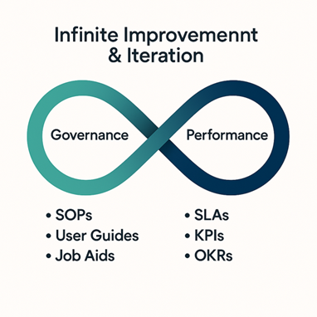
Deloitte will operate Task 9 through a single integrated quality and analytics governance model. The model has four operating commitments. First, governed documentation lifecycle: every SOP, user guide, and job aid has a defined change trigger (regulatory update, system release, recurring QA finding, COR direction), an impact assessment that identifies affected workflows and personnel, a structured drafting and review workflow with named SME and operational reviewers, version control with full edit history, and COR approval before deployment. Second, KPI and OKR alignment: KPIs are derived from the SOW §3.9 data elements (a) through (p) — entity submissions, enrollee data accuracy, reason codes, effective dates, terminations, cancellations, plan-level accuracy, APTC/CSR validations, ASC X12N 834/820 reconciliation, error reports, error correction, error reporting, trending analysis, source/content of common inquiries, vulnerability identification, and additional CMS-identified elements — and refined with CMS at the business process improvement kick-off. OKRs cascade those KPIs to operational targets owned by named team leads.
Third, closed-loop continuous improvement: QA findings, defect trends, and stakeholder feedback flow into a single quality backlog managed in JIRA. Each item is triaged for root cause, assigned an owner, given a target closure date, and tracked through resolution with the corrective action documented. Recurring patterns trigger SOP updates, training refreshes, or system change requests rather than repeated remediation of the same defect. Fourth, decision-useful reporting: each of the three monthly reports closes with specific recommended CMS actions — proposed SOP changes, proposed business rule modifications, proposed system enhancements, or proposed coordination changes with other contractors — backed by the data that supports them. The methods, processes, and tools applied to each Task 9 deliverable are summarized in Table 1.2.8-1.
Table 1.2.8-1. Quality Assurance Methods, Processes, and Tools.
Deliverable | Cadence & Method | Process | Tools
QASP | On Time: Virtual meeting with COR, BO, Business Operations Team, Program Management Team and Incumbent Contractor | 1 Review current ER&R QASP to identify any missed AQLs, SLAs, or KPIs. Locate relevant lessons learned and RAID log entries to discuss history. | MS Word  MS Teams  MS Co Pilot
 | Quarterly: Virtual meeting with COR, BO, Business Operations Team, Program Management Team | 2 Review and discuss draft QASP with emphasis on impact and relevance of AQLs, SLAs, or KPIs to ER&R and submit proposed updates to the COR and request approval | MS Word  MS Teams  MS Co Pilot
 | Quarterly: Publication to CMS intranet | 3 Revise and publish QASP | MS Word  MS Teams  MS Co Pilot
SOPs, User Guides, and Job Aids | Quarterly: Virtual meeting with COR, BO, Business Operations Team and Program Management Team | 1 Identify, record, and review user groups for each document | MS Teams  MS Excel  MS Co Pilot  QA Checklist
 | Monthly: Virtual focus groups with primary users (Case workers, Agents etc.) per session, GTL, Program Management Team | 2 Request feedback on SOP design, recent policy change, or suggestions based on experience | MS Teams  MS Co Pilot  MS PowerPoint
 | Monthly: COR meeting, Business Operations Team and Program Management Team | 3 Summarize design feedback and present recommended updates | MS Teams  MS Co Pilot  MS PowerPoint  QA Checklist
 | Monthly: Program Management Team | 4 Submit proposed updates to the COR and request approval | MS Word  CMS Outlook  CMS SharePoint  CMS Slack  QA Checklist
 | Monthly: Program Management Team | 5 Revise, publish, inform user of updates to SOPs | CMS JIRA  CMS Box  CMS Slack  QA Checklist

The reporting cadence converts day-to-day execution into program intelligence rather than backward-looking metrics. The Quality Assurance Report monitors AQL conformance, sample-based defect rates, escalation patterns, and corrective action status. The Monthly Performance Report tracks every SOW SLA and AQL against the Performance Measurement Plan, with deviations flagged and corrective action plans attached. The Business Process Improvement Report identifies opportunities for SOP simplification, automation, training improvement, and cross-task coordination. The structure and outputs of these reports are summarized in Table 1.2.8-2.
Table 1.2.8-2. Continuous Improvement Reporting Outputs.
Deliverable | Cadence & Method | Process | Tools
Reports | Quarterly: Virtual meeting with COR, BO, Business Operations Team and Program Management Team | 1 Identify, record, and review user groups for each report | MS Teams  MS Excel  MS Co Pilot  QA Checklist
 | Monthly: Draft written report, ETL, visualize data | 2 Produce reports or dashboards | MS Word  MS Excel  QA Checklist  BI Tool
 | Quarterly: Interviews, Surveys | 3 Request feedback on report utility and enhancements | MS Teams  BI Backlog

The most material risk under Task 9 is documentation drift in a dynamic ER&R environment where policy, system, and operational changes are continuous. Left unaddressed, drift produces inconsistent execution, preventable errors, and audit findings. Deloitte mitigates drift through structured change triggers tied to the Federal Register, REGTAP, JIRA system change events, and recurring QA findings; SOP and job aid checkpoint reviews on a published quarterly schedule plus ad hoc review on any substantive change; version control with edit attribution; COR approval tracked against committed turnaround windows; and end-to-end traceability from each business or regulatory change to the corresponding documentation update.
A second risk is the proliferation of well-intentioned but redundant or conflicting metrics. Deloitte mitigates this by ranking proposed measures against three criteria — (1) does it tie to a specific SOW SLA, AQL, or required reporting element; (2) does it produce a CMS decision; (3) does the data exist or require new instrumentation — and presenting the prioritized library to the COR for approval before instrumentation. A third risk is QA cataloging defects without driving improvement; Deloitte mitigates this by integrating QA findings with root cause analysis, mitigation monitoring, and SOP/training updates so each finding measurably reduces recurrence.
Proof points: Deloitte applies this same governance model on Covered California (CalHEERS) where structured documentation lifecycle, monthly performance reporting, and KPI-driven continuous improvement underpin operations for 1.5 million Marketplace enrollees; on Washington Healthplanfinder where 24/7 O&M is governed by the same SOP and QA discipline; and on FinCEN BOI where audited 11,000+ cases averaged a 96% QA score and a 5,000-case backlog was eliminated within three months — directly relevant to the documentation-and-QA-driven operational improvement Task 9 requires.

1.2.9 Task 10: Ad Hoc Work and Special Projects^{(SOW 3.10)} (1.5 Pages)
Our Understanding
Task 10 is CMS' controlled activation lane for short studies, special projects, ad hoc training, the annual FFE Enrollment Manual revision, Death Periodic Data Matching (PDM) consumer response operations, and the Employer Notice Helpdesk. The work is heterogeneous — some is project-based and short-cycle, some is operational and ongoing — but the operating discipline is uniform: rapid activation against COR-confirmed scope, traceable issue handling, dependable reporting, and clean coordination with CMS, federal and state partners, and the broader ER&R contractor ecosystem (Data Services Hub, Eligibility Support, FMPS, MSI, Operations Analytics, Operations Support, Federal Exchange Call Center, Federal Exchange Print, and Stakeholder Engagement). Every Task 10 engagement passes through the same intake protocol so scope, success criteria, deliverable format, and timeline are confirmed in writing before work begins.
Our Approach
Deloitte will operate Task 10 through six structured sub-lanes — short studies and special projects (10.1), ad hoc trainings (10.2), the annual FFE Enrollment Manual revision (10.3), Death PDM (10.4), the Employer Notice Helpdesk (10.5), and SOW-scope catch-all projects (10.6) — each with a defined activation protocol, a CMS-approved scoping artifact, and a Special Projects Tracker entry visible to the COR. The same cross-task SME bench used for Tasks 1–9 (issuer disputes, 1095-A casework, CCHC, FFE updates, notice generation, telephony, IT, SOPs, QA) supplies expertise on demand without standing up parallel capacity. The same Section 2 management governance applies, so Task 10 work neither operates in isolation nor disrupts steady-state operations.
Task 10.1 — Short Studies, Special Projects, and Data Analyses
Deloitte will activate every COR-directed request through a standardized Intake and Scoping Protocol — a lightweight charter capturing problem statement, data requirements, success criteria, deliverable format, and timeline confirmed within two business days before analysis begins. A pre-positioned analytical playbook covers high-frequency study types (improper enrollment, failure-to-reconcile, SEP verification, DMI analysis, duplicate enrollment) with reusable methodologies, data dictionaries, QA checklists, and brief/memo/dashboard shells. Studies execute in CMS' Snowflake and Power BI environment under Task 9 governance, leverage cross-task data already governed under the contract (CERRS casework, 834/820 transactions, HICS flagging patterns), and convert recurring questions into repeatable monitoring products rather than one-off deliverables. Findings touching the 2025 Marketplace Integrity and Affordability Final Rule are framed against current regulatory requirements with awareness of any subsequent legal stays affecting specific provisions, so CMS receives compliance-aware conclusions.
Task 10.2 — Ad Hoc Trainings
Figure 1.2.9-1. [Deloitte to populate: figure title and graphic].
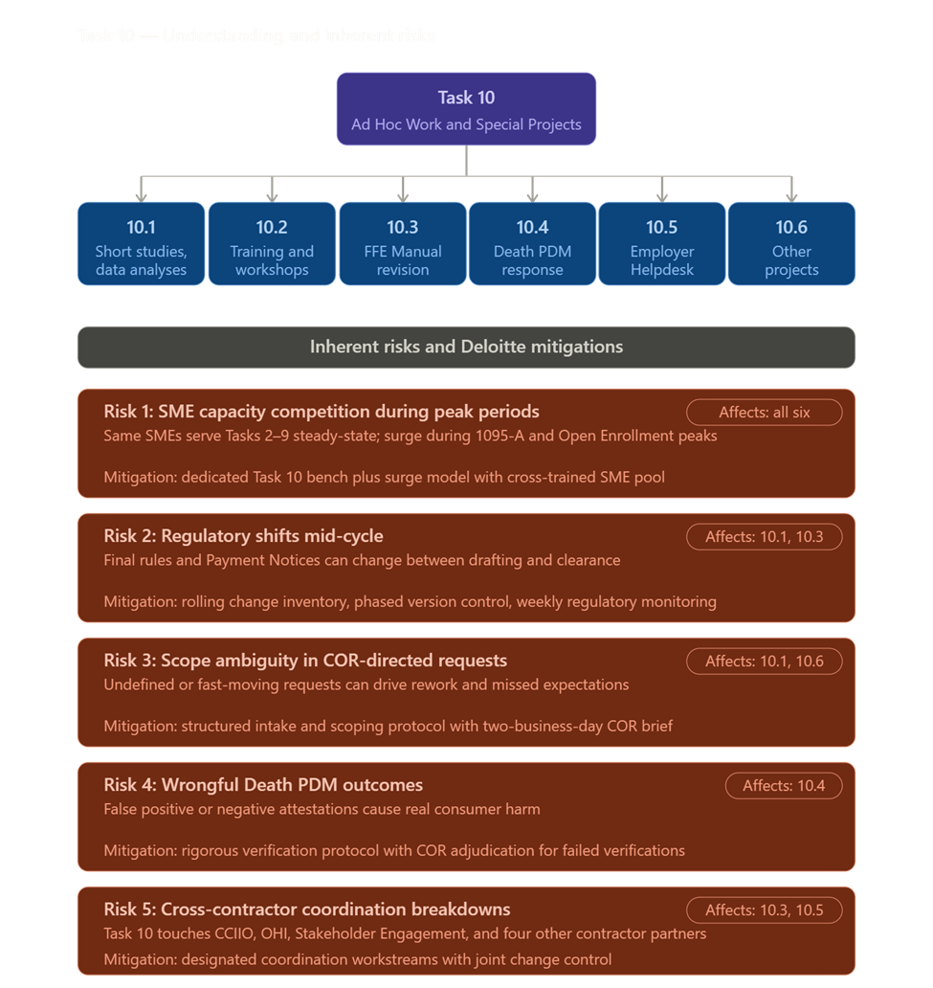
Deloitte will design training backward from desired business outcomes — speed to proficiency, policy adherence, quality, customer experience, reduced handle time — using role-based learning journeys, modular and reusable content anchored to the FFE Enrollment Manual, current SOPs, and live CERRS/HICS/SEED/EDA CORE configurations. Training is paired with human-performance design so format (microlearnings, scenario-based workshops, reinforcement nudges, performance support) matches audience and topic. Section 508 conformance is built into authoring, testing, and delivery; CMS infrastructure is used for hosting (REGTAP for issuer/SBE/assister, MLMS for agent/broker, CMS LMS for internal). Coordination with the Stakeholder Engagement contractor and adjacent contractors (Operations Analytics, FMPS, MSI, Eligibility Support, Federal Exchange Call Center) prevents duplication and aligns logistics.
Task 10.3 — Annual Revision of the FFE Enrollment Manual
Deloitte will operate the January–July Manual cycle as a four-phase project (Preparation, Edit/Review, Clearance, Education and Publication) led by a designated Manual Lead with embedded SMEs from Tasks 2, 3, 4, 8, and 9 — practitioners who see how chapters on DMIs, SEPs, FTR, ER&R, HICS, PDM, UEs, 1095-A corrections, appeals, and HRAs play out in live casework. The Manual Project Plan tracks regulatory inputs (annual Payment Notice, Marketplace Stabilization Rule updates, the annual Letter to Issuers, in-cycle CMS guidance), structured redline proposals, AI-assisted cross-reference and citation checks (with editorial judgment retained by CMS SMEs and Deloitte content leads under a human-in-the-loop model), version control with edit attribution and decision logs, and a Manual Change Log accessible to the COR capturing every accepted/deferred/rejected change. The final Manual hands off cleanly to Stakeholder Engagement with a substantive change summary and quick-reference change matrices for issuers and SBEs, and Manual updates flow into ER&R operations through SOP, QA checklist, training, and CERRS/HICS configuration refresh under Task 9.
Task 10.4 — Death Periodic Data Matching
Deloitte will operate Death PDM as a campaign-based, surge-ready response lane aligned to the twice-yearly cycle. The toll-free line (with TTY and outbound callback) routes through Deloitte's existing ER&R contact center infrastructure under Task 7 with logical separation to protect caller privacy and dignity. A small specialized team is trained in trauma-informed, empathetic call handling for grieving family members and living individuals who received a wrongful death notice. Every call follows a rigorous attestation verification protocol (identity-verifying details, cross-reference against the CMS-provided notified-deceased list, escalation of failed verifications) with a single authoritative attestation log providing audit-ready traceability. Attestation receipt notices generate on a rolling basis under Task 6. Deloitte delivers the SOW-required weekly running list of successfully matched attestations to the FFE via secure email beginning the day the line opens, and submits post-cycle reporting capturing call volume, attestation rates, verification outcomes, common caller concerns, and any patterns suggesting SSA data quality issues or notice-content improvements.
Task 10.5 — Employer Notice Helpdesk
Deloitte will operate the Employer Notice Helpdesk on existing ER&R contact center infrastructure (meeting the SOW preference for an existing system solution) with a dedicated toll-free line and TTY supporting real-time inbound, voicemail, outbound callback, and warm transfer to the OHI employer appeals call center, M-F 8 AM–8 PM ET excluding federal holidays. A CMS-approved script anchors current Employer Notice content and the underlying policy framework (employer-coverage affordability, minimum value, ICHRA/QSEHRA, appeals pathways) with a structured update cycle on notice changes, regulatory updates, or recurring caller patterns. An organized triage protocol classifies every contact, routes appeals to OHI, escalates suspected notice or data issues to CMS, and resolves informational inquiries at first contact. A single tracking system captures every call and voicemail with timestamp, employer identifier, inquiry category, disposition, transfer/escalation path, and resolution notes — providing audit-ready traceability and the data foundation for required weekly, monthly, and annual reports. Recurring caller themes surface to CMS as actionable feedback so the Helpdesk informs notice and policy refinement, not just inbound resolution.
Task 10.6 — Projects Related to the Scope of the SOW Inclusive of All Tasks
Deloitte will treat the catch-all clause as a structured intake channel rather than unbounded scope. Every request applies the Ad Hoc Request Intake and Scoping Protocol from Task 10.1, rolls into the Special Projects Tracker for unified COR visibility, draws on the cross-task SME bench from Tasks 1–9, and applies Deloitte's surge-support model to scale resources up for short-duration projects without disrupting steady-state operations. Recurring requests convert to right-sized operational capabilities under Task 9 (dashboards, SOPs, task-level enhancements) so repeat work is institutionalized rather than re-executed.
Proof Point
Rapid activation of targeted federal support operations: Deloitte rapidly deployed a targeted contact center for CDC's Vaccine Administration Management System (VAMS) on AWS Connect to support end users, jurisdictions, and clinics during high-volume rollout, backed by training, QA, reporting, SLA monitoring, and knowledge management — supporting the administration of 9.5 million vaccines. The same activation discipline, structure, and reporting cadence apply to every Task 10 sub-lane.
Table 1.2.9-1. Task 10 Capabilities Summary.
Process Phase | Activities & Approach
Program Integrity | Embed program integrity throughout client, stakeholder, and contractor/front line staff using change campaigns and continuous reinforcement with emphasis on social engineering and fraud.
AI fluency | Prepare frontline staff for transition to AI-empowered operating model throughout transition by training new workflows, where to exercise human judgment, and ethical use. Empower CMS leaders with AI fluency to guide decision making and identify potential risks and limitations.
Dispute root-cause trend study | Patterns by dispute type, system touchpoint, issuer segment, and recurrence; includes prevention recommendations and which SOPs/job aids should change.
“Dispute prevention playbook” workshop (issuers + internal): | Common triggers, documentation standards, decision rules, and “avoid repeat submissions” guidance.
High-complexity case workflow study | Map steps, handoffs, rework loops, and time sinks; produces an “automation opportunity register” (what to automate now vs later).
Dashboard literacy training (role-based) | How to interpret KPI/SLA views, how to spot anomalies, and how to translate insights into backlog items.
Surge onboarding micro-trainings (internal staff) | Short, scenario-based modules for open enrollment/tax season, including call-center and caseworker variants.

1.3 Sub-Section 1C: Understanding and Mitigation of Risks (2 Pages)
Taking over a highly complex, mission-critical IT ecosystem from an incumbent vendor is inherently risky—yet it is a challenge Deloitte has successfully navigated for the nation’s largest federal and state health agencies. We recognize that the Enrollment Resolution & Reconciliation (ER&R) program operates in a highly visible, zero-fail environment. Disruptions in data reconciliation, Form 1095-A generation, or Complex Case Help Center (CCHC) operations directly impact the financial security and healthcare access of over 24 million Americans.
Deloitte brings a proven "Zero Disruption" transition methodology, forged through our experience executing seamless takeovers and system rescues across the government health sector. For example, when Covered California (CalHEERS) faced critical monolithic system failures and contact center outages during peak Open Enrollment, Deloitte successfully took over the infrastructure, rapidly migrating the exchange to a resilient cloud architecture without interrupting consumer access for its 1.75 million enrollees. Similarly, we manage the continuous operation and modernization of the Washington Healthplanfinder—recently supporting a record 28% surge in open enrollment sign-ups—and lead the transition of complex Medicaid Enterprise Systems (MES) across states like Tennessee, Ohio, and Virginia.
Our Approach: | Effective risk and issue management is a core part of Deloitte’s project management principles. One of our key strengths is our vast network of professionals across different domains, industries, and geographies. We leverage this network to share knowledge and best practices from our diverse portfolio of projects. This enables us to proactively apply lessons learned and bring together the firm's strengths when our clients are faced with new external risks. Our culture of client excellence makes us focus on the success of our clients, not just the technology project we are running. We consider each situation and the ecosystem holistically and strategically, allowing us to identify potential risks and enabling a comprehensive risk mitigation/response. An example of this collaboration and holistic risk response and mitigation is the recent Public Health Emergency and the corresponding unwinding efforts.

For ERR, Deloitte has identified the ten most vital, high-level program risks spanning the full scope of this task order — covering enrollment data integrity, consumer experience, IT systems, security, program management, and transition operations. Our risk assessment is informed by Deloitte's direct experience managing similar Marketplace enrollment, reconciliation, and consumer support programs in other states, where we have encountered and resolved the same operational pressures, seasonal volume surges, and data alignment challenges that define this program. That state-level experience — combined with our deep understanding of the CMS operational environment — allows us to anticipate where this program is most likely to face disruption, not simply list theoretical risks. For each risk, we provide a targeted mitigation strategy grounded in what has worked in comparable program environments and aligned to the specific requirements of this SOW. Following the risk register, we describe the continuous risk identification and management discipline we will apply throughout the life of this contract.
Table 1.3-1. Risk and Mitigation Strategies.
Risk Area | Description & Impact | Mitigation Strategy
Transition-In & Knowledge Transfer | Incomplete or delayed transfer of institutional knowledge from the incumbent contractor — including undocumented business rules, system configurations, and SOPs — could degrade performance during the 3-month transition-in window and produce missed SLAs, unresolved disputes, and consumer-facing errors immediately after takeover. | Execute a structured Transition-In Plan submitted within 8 business days of award, with a Joint Operating Agreement signed with the incumbent within 7 calendar days. Deloitte will: (1) deploy TruNorth GenAI to capture rule logic, routing rules, and classification behavior directly from CERRS, HICS, SEED, and EDA CORE source code, supplementing what the incumbent shares through SOPs and KT; (2) shadow incumbent operations for issuer disputes, 1095-A casework, and CCHC; (3) validate every workflow, data pipeline, and intake channel against live production behavior through structured readiness gates before any case transfer; and (4) report progress through a daily cross-task readiness dashboard to the COR.
Seasonal Volume Surges & Workforce Scalability | Form 1095-A consumer dispute volumes triple during tax season (January–May), and ER&R volumes peak for 120 days after Open Enrollment close. Failure to recruit, onboard, clear, and train the SOW-required ~100–120 temporary case analysts and 4 temporary team leads on time will breach the 2/5/10 business-day SLAs in SOW Table 4 and generate consumer harm during the highest-stakes period of the year. | Maintain a pre-qualified surge staffing pipeline refreshed annually. Begin recruitment in November and start CMS background investigations at offer acceptance so the first wave is cleared, system-trained, and shadow-certified before January 1. Apply a returner-first model so prior-season caseworkers reach full productivity from day one. New hires train on prior-year root-cause case types under peer certification by returners. Release surge capacity in phases as volumes decline through June. Monthly tax-season readiness reports are submitted to the COR beginning in October.
PII / PHI / FTI Data Breach | ER&R systems process Personally Identifiable Information, Protected Health Information, and Federal Tax Information for ~24 million Marketplace consumers. A breach — whether through credential compromise, misconfigured cloud storage, exfiltration via subcontractor access, or insider misuse — triggers HHS/CMS one-hour incident reporting, OMB M-17-12 breach response, IRS Safeguards review for FTI, congressional notification, and lasting reputational impact. | Implement HHS/CMS-approved encryption with current FIPS 140 validation in transit and at rest for every system component. Apply role-based access control with field-level masking for PII fields in CERRS and HICS. Conduct quarterly third-party (3PAO) penetration testing against the FedRAMP-compliant Azure Government enclave. Maintain a documented Incident and Breach Response Plan tested twice per year, with one-hour reporting to the CMS IRT pre-staged through CMS Help Desk and IT Service Desk channels. Continuous monitoring is operated by a CISSP-certified Security & Privacy Officer with SOC integration.
Regulatory & Policy Changes Mid-Contract | ACA regulations, IRS guidance, CMS policy updates, the annual Payment Notice, and Marketplace integrity rules can alter dispute processing rules, Form 1095-A content, SOP requirements, and system logic mid-contract. A delayed response generates downstream consumer disputes, issuer complaints, and Enrollment Manual misalignment. | Designate a Policy Watch function within the program management team that monitors the Federal Register, CMS guidance releases, REGTAP updates, and the Letter to Issuers continuously. Maintain a 30-day SOP rapid-update process pre-approved by the COR for non-substantive changes, with a structured change-impact assessment for substantive changes. Integrate Policy Watch outputs into the Annual Enrollment Manual revision under Task 10 so manual updates and CERRS configuration changes are coordinated, not sequenced.
Fraud, Unauthorized Enrollments & Program Integrity | Unauthorized plan switches (UPS), unauthorized enrollments (UE), demographic data obfuscation patterns, and improper APTC payments create undetected overlapping coverage, incorrect tax statements, and program-integrity vulnerabilities at the intersection of Tasks 2, 3, 4, and 8. | Analyze every new Marketplace enrollment for data anomalies consistent with UPS and UE patterns on a daily cadence. Implement rules-based detection models in coordination with the Center for Program Integrity (CPI) and OPOLE; refresh detection logic monthly based on emerging patterns. Embed program-integrity-by-design controls — supervisor sign-off before any retroactive override or batch correction, elevated QA sampling for high-risk case types, and a cross-task integrity risk register — into every dispute and casework workflow rather than running integrity as a periodic audit.
Automated Business Rule Failures | ER&R relies on automated rules to resolve approximately 99% of payment disputes, 95% of enrollment disputes, and 100% of SBE disputes (~6.1 million automated resolutions in 2024). A defective, outdated, or misconfigured rule could incorrectly resolve large volumes of disputes within hours, producing incorrect 1095-A forms and improper APTC payments at scale. | Operate the rule library through a governed lifecycle: every change moves through peer review, sandbox testing on prior-year case data, COR notification, and parallel-run validation against existing rule output before promotion. Manage rule changes through the existing JIRA process. Apply daily monitoring of resolution rates by dispute type with deviation triggers that distinguish rule failure from upstream data quality from new volume patterns — each driving a different corrective action.
Service Level Agreement Performance Under Concurrent Peak Load | SOW Tables 3 and 4 require 95% of high-complexity issuer disputes resolved in 10 days and 1095-A consumer disputes resolved in 2/5/10 business days by complexity tier. During February–March, when 1095-A volume peaks concurrently with Open Enrollment close-out and the BUU correction cycle, simultaneous SLA pressure across Tasks 2, 3, 4, and 5 creates compounding breach risk. | Apply a unified case-routing dashboard that starts the SLA clock at intake and triggers early intervention when any case trends toward 70% of its SLA window. Cross-train the surge workforce so a 1095-A medium-complexity caseworker can absorb high-complexity overflow under supervisor escalation. Maintain a published peak-load capacity matrix covering supervisory ratios, QA coverage, and reserve activation thresholds at three concurrent volume scenarios so capacity does not degrade when caseload spikes.
FFE Update Sequencing & BUU Cycle Errors | Task 5 BUU submissions, Update Policy API calls, and Hard Case updates must be sequenced correctly relative to the ~22 annual 1095-A correction cycles and the monthly Recon Run Calendar. A sequencing error or a missed pre-validation does not 'fail' visibly — it creates a new data problem that surfaces weeks later as a downstream dispute or a corrected/voided 1095-A. | Treat FFE submissions as a precision execution function with full pipeline visibility to CMS at every stage. Map the downstream consequence of every retroactive action — which correction cycle it falls into, whether a corrected or voided 1095-A is generated, and the correct submission order — before any update is queued. Require supervisory sign-off with a complete time-stamped audit trail for batch corrections and manual overrides. Run automated pre-validation that the Operational Analytics Contractor and the QA Team can independently confirm before each submission window.
FedRAMP / ATO Authorization & Continuous Monitoring | CERRS, HICS, SEED, and EDA CORE operate inside the CMS Microsoft Azure Government (MAG) enclave with the Snowflake EDA CORE deployment requiring FedRAMP sponsorship. Lapses in continuous monitoring artifacts, POA&M discipline, or 3PAO assessment cadence could suspend or revoke an ATO and force operational restrictions during a period of mission-critical casework. | Maintain ATO continuity through a Security & Privacy Officer-led continuous monitoring program with monthly OS/database/web/network vulnerability scan delivery, POA&M updates against the HHS standard (15-day critical / 30-day high / 90-day medium / 360-day low), 3PAO annual reassessment scheduled outside Open Enrollment and tax season, and FedRAMP sponsor obligations for the Snowflake deployment governed as a standing responsibility rather than ad-hoc activity.
Cross-Contractor Coordination Dependencies | ER&R cannot be delivered in isolation — performance depends on continuous coordination with the CMS Data Services Hub (DSH), Eligibility Support, Federal Exchange Call Center, FMPS, Marketplace System Integrator (MSI), Operations Analytics, Operations Support, Federal Exchange Print, and Stakeholder Engagement contractors. A misaligned interface, an undocumented schedule change, or a transition gap at any of those boundaries creates downstream casework volume Deloitte cannot prevent unilaterally. | Establish a standing cross-contractor coordination cadence anchored to the SOW interfaces: weekly CMS issuer calls, monthly SBE calls, daily operational reconciliation workgroup participation, and structured handoff protocols documented in the Project Implementation and Oversight Plan. Maintain interface monitoring on every external dependency (Operations Analytics for reconciliation files; Print Contractor for notices; DSH for SOAP/HTTPS exchange) with alerts when latency or error rates breach thresholds — surfacing other-contractor issues to CMS through the COR with root-cause analysis rather than absorbing them silently.

Processes to Identify Additional Risks
Deloitte will apply a structured, six-phase risk management lifecycle throughout the period of performance — a framework refined through years of leading large-scale federal program takeovers and system transitions across the United States. This process is not limited to the risks identified above — it is designed to surface and address new risks as they emerge across all ten SOW tasks, all contract years, and all phases of the enrollment and tax reporting cycle
Table 1.3-1. Risk Register and Mitigation Strategies.
Process Phase | Activities & Approach
Ongoing Identification | Risks are identified through multiple continuous channels:  - Weekly COR meetings: standing agenda item for emerging risks and issues  - Monthly Progress Reports: risk register reviewed and updated with new entries, status changes, and closures  - Monthly QA audits: operational data analyzed for performance degradation patterns that may signal emerging risks  - Continuous monitoring dashboards: real-time alerts on SLA performance, system uptime, and dispute aging  - Staff feedback loops: frontline analysts and developers surface operational risks through weekly team stand-ups  - Cross-contractor liaison: interface issues flagged as risks before they become incidents
Risk Scoring & Prioritization | Each identified risk is scored on two dimensions:  - Probability: Likelihood of occurrence (High / Medium / Low) based on historical data, contract context, and expert judgment  - Impact: Consequence severity across cost, schedule, performance, and government oversight burden  - Composite risk score drives prioritization: High/High risks escalated to COR within 24 hours; Medium risks addressed in the next weekly meeting; Low risks tracked in the register
Mitigation Planning & Execution | For each risk above the Low threshold:  - A Mitigation Action Plan (MAP) is developed within 5 business days of identification, owned by the responsible Project Manager  - The MAP defines specific actions, owners, target dates, and success criteria  - Progress against MAP actions is tracked in the risk register and reported monthly to the COR  - Residual risk is re-scored after mitigation to confirm acceptance or trigger additional action
Escalation to CMS | Risks that meet any of the following criteria are escalated to the COR immediately:  - Probability and impact are both High  - Risk involves PII/PHI/FTI exposure or a potential security incident  - Risk could cause a missed statutory deadline (e.g., January 31 Form 1095-A mailing)  - Risk requires resources, decisions, or actions outside the Contractor's authority  - [Offeror Name] will never self-manage a risk that requires Government awareness or action
Quarterly Risk Reviews | In addition to continuous monitoring, [Offeror Name] will conduct formal quarterly risk reviews that:  - Reassess the full risk register — close resolved risks, update status on active risks, and identify new risks from the prior quarter's operational data  - Incorporate lessons learned from any SLA misses, incidents, or near-misses in the quarter  - Adjust mitigation strategies based on regulatory changes, volume trends, and system evolution  - Present findings to CMS at the quarterly in-person meeting with recommended actions
Lessons Learned & Continuous Improvement | At the conclusion of each contract year, [Offeror Name] will conduct a formal lessons-learned review that:  - Documents risks that materialized and evaluates whether mitigation strategies were effective  - Identifies risk categories that were under-estimated and recalibrates the risk model for the following period  - Feeds findings into the annual SOP update cycle and the Task Order Summary Report  - Shares relevant lessons with CMS and partner contractors to reduce program-wide risk exposure

2.0 Section 2: Management Approach, Quality Assurance and Surveillance Plan, and Staffing Plan (Total 11 Pages)

2.1 Sub-Section 2A: Management Approach (6 Pages)

2.1.1 Task 1: Program Implementation and Oversight (PI&O) ^{(SOW 3.1)}
ER&R is not a single program — it is twelve interlocking tasks, four production systems, and a casework operation that touches more than 24 million Marketplace consumers each year. Disciplined program management is what keeps that operation running when issuer dispute volumes hit four million annually, when 1095-A volumes triple in February, when a single business-rule change can ripple across five State-Based Exchanges, and when a regulatory update lands mid-cycle. Deloitte will manage this task order through a single integrated operating model anchored to the SOW §3.1 schedule of obligations: contract kickoff within 12 business days of the start of the base period, a draft Project Implementation and Oversight Plan (PIOP) within 7 business days, the final PIOP within 60 days, and a working operating cadence in place from Day 1.
The PIOP is the primary management instrument and Deloitte's commitment of record to CMS. The PIOP will document Deloitte's approach across every project management knowledge area required by Attachment 2 §2A — scope management, time management, cost management, communication management, information security and privacy management, subcontractor monitoring, and risk and issue management — and will incorporate the work breakdown structure (WBS), schedule, milestones, key personnel, technology and AI transparency, and the structured collaboration model with CMS staff and other CMS contractors. The PIOP will be updated quarterly and ad hoc as conditions change, and Deloitte will not commit to any major staffing or ODC action without prior COR approval. Tooling discipline reinforces the plan: an integrated RAID log, a decision log, a milestone dashboard, and a JIRA-based change request backlog all maintained in a CMS-accessible workspace so the COR has continuous visibility, not periodic snapshots.
Reporting cadence and meeting discipline are the engine that makes the PIOP operate as a living document rather than a one-time deliverable. Deloitte will deliver the Monthly Progress, Data and Cost Report by the third Monday of each month — two days before the Monthly Budget Review — covering task-by-task activity narrative, upcoming meetings and actions, outstanding issues requiring CMS action, unresolved items from the prior month, and full cost tracking by labor category, hours, rates, subcontractor costs, travel, ODCs, indirect costs, and total costs aggregated and broken out by task and sub-task. The monthly Form 1095-A Consumer Disputes and Enrollment Process Improvement Report will deliver prioritized, evidence-supported improvement recommendations covering the eight content elements in SOW §3.1 (education needs, triage and enrollment process changes, system integration, system efficiency improvements, regulatory authorization needs, cost-benefit analysis, stakeholder coordination, and data-churn reduction). Weekly meetings begin the week after kickoff with agenda one day prior, minutes within two business days, and at least four in-person meetings per year in the Baltimore-Washington corridor or at a CMS Regional Office. The Task Order Summary Report will deliver in draft in the 10th month of the final period of performance and final 30 days before task order end.
Risk and issue resolution is governed through the same six-phase risk management lifecycle described in Sub-Section 1C. Risks are identified continuously across all ten SOW tasks, scored for likelihood and impact, assigned an owner, and tracked to closure with mitigation actions documented in the RAID log and reviewed weekly. Communication runs through the COR as the single technical-direction channel, with a structured communication plan covering CMS, the Eligibility Support Contractor, the Federal Exchange Call Center Contractor, FMPS, the Marketplace System Integrator, the Operations Analytics Contractor, the Operations Support Contractor, the Federal Exchange Print Contractor, and the Stakeholder Engagement Contractor. Subcontractor work is governed under the same SLAs, QA standards, and reporting discipline that apply to Deloitte's prime work and is monitored through the Small Business Liaison Officer (Section 4) and the integrated quality program (Sub-Section 2B). Information security and privacy management is led by the Security & Privacy Officer (Section 3.1) and operates as a continuous control function, not a periodic compliance review.
Table 2.1.1-1. Approach Summary.
Column Heading | Description
Project Implementation and Oversight | Scope Management. The PIOP will include a clear task-to-scope alignment that maps implementation and oversight activities directly to the SOW. This will demonstrate how startup, governance, staffing, technical readiness, reporting coordination, and management oversight support performance of the ER&R scope rather than functioning as disconnected administrative efforts. By structuring the PIOP this way, we will provide CMS with traceability from contract requirements to implementation activities, milestones, and management controls. The PIOP will also establish the baseline for scope management by defining how clarifications, adjustments, or requested changes will be reviewed, approved, and incorporated in a controlled manner.  Time Management. Our PIOP will include an integrated implementation roadmap with detailed milestones and workstream-level sequencing. The schedule will be built around the activities required to establish operational control and readiness, including knowledge transfer, access and environment readiness, documentation review, systems and interface setup, testing, cutover, stabilization, and transition to steady-state operations. We will account for operationally sensitive periods, workload peaks, and business-critical cycles so implementation activities are aligned to the realities of ER&R performance and do not create avoidable operational risk. Because transition, stabilization, casework readiness, technical setup, reporting coordination, and operational support activities must often proceed in parallel, the PIOP will define the sequencing logic, dependency controls, and management checkpoints needed to keep simultaneous workstreams aligned.  ER&R workloads are affected by seasonal peaks, dispute spikes, and time-sensitive processing cycles. Our management approach includes proactive planning for these periods through readiness reviews, volume forecasting, resource flexing, temporary staffing strategies, and surge-specific oversight controls. We will distinguish between casework surge and contact center surge, since each requires different staffing models, leadership controls, and quality approaches. This ensures the program remains prepared ahead of high-volume periods rather than reacting only after workloads increase. This is particularly important around Form 1095-A and tax-season activity, which are recurring pressure points for consumer volume and casework intensity. Known business-cycle peaks should therefore be managed as expected operational conditions, not as exceptions.  Key Milestones and Target Dates. XXX  Information Security and Privacy Management. To safeguard sensitive data such as Personally Identifiable Information (PII), Protected Health Information (PHI), and CMS financial data, strict controls must be implemented across physical, technical, and administrative domains. These measures ensure compliance with regulatory requirements such as HIPAA, HITECH, and CMS security standards while securing data integrity, confidentiality, and availability. Data encryption is a cornerstone of data security, protecting information both in transit and at rest. Advanced Encryption Standard (AES-256), recognized for its robustness, should be utilized with Federal Information Processing Standards (FIPS) 140-2 compliant algorithms. Sensitive data such as PII and PHI can benefit from a multi-layered encryption approach that combines AES-256 for data protection and RSA encryption for secure key management. Furthermore, Transport Layer Security (TLS), Virtual Private Networks (VPNs), and Internet Protocol Security (IPSec) protocols should be employed for secure communications across network components. User authentication and access controls are critical for securing sensitive data. Implementing Multi-Factor Authentication (MFA), Single Sign-On (SSO), and Role-Based Access Controls (RBAC) ensures access is granted based on the principles of Least Privilege Access (LPA). These mechanisms restrict unauthorized access and enhance operational efficiency. Routine security audits and vulnerability assessments should be conducted to identify and address potential risks. Vulnerability scanning tools, penetration testing, and security audits are vital for evaluating the security posture of networks, systems, databases, and applications. System hardening measures like patch management and continuous monitoring help proactively remediate vulnerabilities and protect against malicious actors. To further protect sensitive data, physical safeguards should secure facilities housing data from environmental hazards and unauthorized intrusion. By integrating these stringent controls, we can effectively safeguard sensitive data while adhering to CMS security guidelines and other regulatory requirements.  Subcontractor Management. Ensuring seamless integration of subcontractor activities into the overall project plan necessitates clearly defined processes, robust monitoring, and active collaboration. Deloitte employs a comprehensive approach to managing subcontractors, integrating them as part of a unified team while maintaining accountability through performance metrics and reporting. Deloitte requires subcontractors to submit regular status reports, typically monthly, detailing their progress, plans for upcoming tasks, issue and risk statuses, and budget updates. These reports are closely monitored to ensure alignment with project milestones and quality standards. Should performance gaps arise, Deloitte implements a proactive mitigation process, requiring subcontractors to develop a Remedy Action Plan that proposes corrective measures to address identified challenges.  Organizational Chart. X
Financial Planning and Management | Cost Management. We will closely manage costs and integrate efficiencies into our work to drive the highest possible return on CMS’ investment. Internally, our XX Lead, will manage and monitor the project budget and conduct regular forecasting exercises using our established financial management system and a detailed spend plan that aligns to schedules, resources, and milestones for each model, task and the project overall. We will closely monitor spend, especially as it relates to surge and peak-period readiness. We will build on our experience creating tailored financial reports including XX example.
Risk Planning and Mitigation | The PIOP will also establish our approach to Risk Planning and Mitigation. It will define how risks will be identified, assessed, scored, monitored, mitigated, escalated, and retired over time. It will also describe how contingencies, alternate work strategies, schedule buffers, and management decision points will be used to protect continuity of operations and respond to unexpected challenges. Risk management will be integrated into the normal management cadence so emerging threats to schedule, staffing, technical readiness, performance, or stakeholder coordination are addressed in a timely and visible manner.  Example Risk and Mitigation Strategy:
Issue Resolution | The PIOP will define our approach to Issue Resolution. It will document how operational, technical, and programmatic issues will be identified, logged, triaged, assigned, escalated, tracked to closure, and incorporated into management decisions and corrective action processes. This includes both day-to-day operational issues and more complex enrollment and reconciliation issues that require structured coordination across teams. By defining issue management within the PIOP, we will ensure that issue resolution is disciplined, visible, and directly connected to the broader oversight model rather than being handled informally.
Communications with all stakeholders, including CMS | Communication Management. Deloitte will be responsive to the many stakeholders, internal and external, crucial to this project. Our Communications Plan, part of our PIOP, will clearly define communication channels across our team, and with stakeholders we interact with during delivery. It will define the forums, cadences, reporting pathways, agendas, milestone updates, escalation channels, and collaboration mechanisms that will be used to maintain alignment with CMS, the COR, and other stakeholders throughout performance. It will also document how we will support kickoff materials, weekly meeting preparation, periodic in-person meetings, stakeholder coordination points, and communication needed to sustain visibility, transparency, and decision-making across the program.  We will present the draft PIOP, our overall implementation approach, and our Implementation and Oversight Team during the contract kickoff meeting. Following kickoff, we will update the PIOP to incorporate CMS decisions, clarified priorities, agreed timeline changes, and any management adjustments identified during startup discussions. After adjudicating CMS feedback, we will finalize the PIOP and maintain the CMS-approved version throughout the period of performance as a living management document

Figure 2.1.1-1. [Deloitte to populate: figure title and graphic].
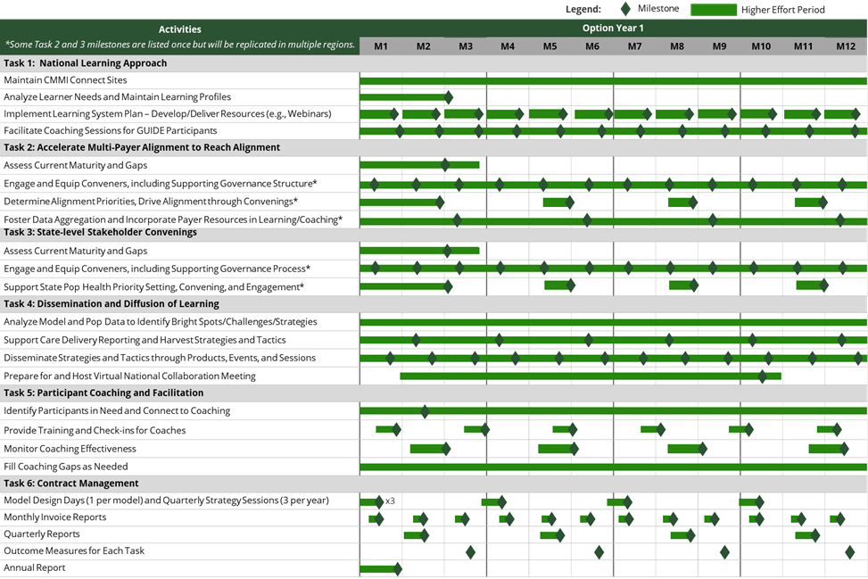

Table 2.1.1-2. Illustrative Milestone Measures by Task.
Task | Illustrative Measures
Task 1: National Learning Approach | - Connect download rates of materials supporting care delivery requirements  - % of participants engaging in peer-to-peer learning events and other webinars
Task 2: Accelerate Multi Payer Alignment | - Meeting agendas regularly include alignment discussion and priority items  - Two or more payers (other than CMS) engaged for each state
Task 3: State-level Stakeholder Convenings | - Meeting agendas regularly include discussion of the agreed upon priority health outcomes  - Participants agree upon measures used to report out on progress towards priority health outcomes
Task 4: Dissemination and Diffusion of Learning to Participants | - # of shared learnings disseminated  - Download/view rates of webinars, podcasts, guides, etc.  - % of states engaged in dissemination activities
Task 5: Participant Coaching and facilitation | - # of participants assessed for coaching needs  - # of local coaches/ facilitators available in each state
Task 6: Performance Requirements | - On time submission rate of reports  - Consistent meeting schedule with CMS

2.1.2 Task 11: Transition-Out (Optional) ^{(SOW 3.11)}
Our Understanding: We understand that supporting a transition-out to a new vendor is a high-visibility, time-bound effort that must balance rapid execution with uninterrupted mission support, clear accountability, and strict compliance. Success depends on establishing a COR-approved operating framework quickly, coordinating closely with the incoming vendor while managing dual operations during the overlap period, and transferring in-flight work, documentation, and operational knowledge in a complete, orderly, and verifiable manner. We also understand that transition-out introduces heightened risk around ownership of work products, version control across repositories, and cutover sequencing, particularly when security, ATO, PII, GFE, GFI, and access approvals are on the critical path. In this environment, CMS needs a transition partner that can maintain continuity, reduce rework and service disruption, and provide the governance, transparency, and discipline required to enable a smooth, compliant handoff to the successor vendor.
Our Approach: We create a detailed Transition-Out Plan to ensure a seamless handover of responsibilities to the incoming contractor or CMS is essential to prevent disruptions and maintain operational excellence. This plan will focus on documentation, knowledge transfer, and alignment of operational priorities, ensuring the continuity of services and adherence to CMS objectives.
Potential Roadblocks: When supporting a transition-out of another vendor, Deloitte recognizes that the most common challenges are compressed transition timelines, the need to coordinate dual operations while maintaining service continuity, incomplete or uneven transfer of in-flight work and operational artifacts, and security and ATO constraints tied to PII, GFE, GFI, and access changes. We mitigate these risks through a disciplined, transparent transition approach that begins with Day 1 governance, a JOA-ready operating framework, and an integrated RAID log, decision log, and milestone-based transition plan to keep all parties aligned and issues escalated quickly. To enable an orderly handoff, we use a structured artifact transfer register with defined completeness criteria, version control, owner-of-record accountability, and formal handoff thresholds, reinforced through knowledge transfer sessions, shadow operations, and phased cutover readiness reviews to reduce rework and avoid disruption. In parallel, we establish a dedicated security and privacy workstream to baseline sensitive assets, map approval dependencies, maintain POA&M discipline, and enforce security readiness gates so that access changes, cutovers, and final turnover occur in a controlled, compliant, and low-risk manner.
Our Successes: Deloitte successfully supported the transition-out of the previous system integrator vendor on California state-based marketplace project in 2020 in less time than expected and during a global pandemic. The successful transition-out of the previous vendor is a testament to the dedication Deloitte has to close collaboration, coordination, and knowledge transfer with the outgoing vendor.
The Transition-Out Plan will begin with comprehensive documentation of all processes, workflows, and system configurations. This includes maintaining and continuously updating project documentation throughout the contract period to provide a solid foundation for the incoming contractor. The documentation will encompass Tier 2 Help Desk processes, key points of contact, the location of relevant documentation, the status of ongoing tickets and initiatives, and a comprehensive inventory of technical and project management artifacts. Knowledge transfer will be supported through shadowing, reverse shadowing, and walkthrough sessions. The Transition-Out Plan will include establishing governing forums with senior leaders from CMS, the outgoing team, and the incoming contractor to guide, direct, and escalate transition activities. Regular status meetings, steering committee discussions, and transition review meetings will ensure alignment of operational priorities and provide a platform for addressing challenges promptly. Detailed process maps, workflow documentation, and project deliverables will be shared with the successor contractor, alongside a clear communication and issue resolution protocol to minimize misunderstandings and delays.
Throughout the transition, the integrity and continuity of CMS operations will remain a priority. By adhering to a rigorous, disciplined approach and maintaining ongoing communication and collaboration, the outgoing contractor will ensure a seamless transfer of responsibilities that aligns with CMS’s strategic goals without disrupting ongoing operations or compromising objectives.

2.1.3 Task 12: Transition-In (Optional) ^{(SOW 3.12)}
Our Understanding: We understand the CMS Transition-In as a time-bound, high-visibility effort that must preserve operational continuity while establishing the foundation for long-term delivery success. A successful transition will require close coordination among CMS, the incumbent, and our team across four interconnected dimensions:
- Governance and Agreement: Timely execution of the Joint Operating Agreement (JOA) within 7 calendar days, supported by disciplined transition governance, RAID management, and a decision log aligned to the Task 1 Project Implementation and Oversight Plan (PIOP).
- Integrated Planning: Rapid development of an initial Transition Management Plan – delivered within 8 business days – that integrates with the PIOP and reflects a realistic critical path with COR-aligned milestones.
- Comprehensive Discovery: Establishment of a clear baseline of the current environment – covering systems, interfaces, data (including PII), in-flight activities, licenses, warranties, SOPs, and security/ATO status – so that responsibilities can be transferred with full operational, technical, and compliance visibility.
- Phased Operational Handoff: A structured 12-week transition that progressively shifts accountability from the incumbent to our team through shadow operations, artifact validation, and workstream-level cutovers, concluding with COR-accepted exit criteria and a smooth handoff to steady-state operations.
Deloitte brings proven experience executing complex government transitions – including the Wyoming integrated eligibility and data center transition, Texas DIR transitions, and California infrastructure migration to cloud operations – and our existing familiarity with CMS systems and environments means we can compress the early discovery and access provisioning phases that typically consume the first weeks of a transition. Our methodology is built on rigorous entry and exit criteria, continuous risk evaluation, and disciplined knowledge transfer, and our head start positions us to deliver a faster, lower-risk transition from day one.
Our Approach: Our approach is to execute the transition in a structured, low-risk manner that combines strong governance, rigorous discovery, and phased operational handoff. We will quickly stand-up transition governance with the CMS COR and incumbent, establish RAID and decision logs, and complete JOA review and execution within the required timeframe to support dual-operations management and coordinated communications. In parallel, we will submit an initial Transition-In Plan, conduct structured knowledge transfer and walkthroughs, enable controlled access, and progressively assume responsibilities over the three-month transition period. We will then manage phased cutovers by workstream or system, validate exit criteria with the COR, and focus on stabilization to ensure a smooth transition to steady-state operations. The table below outlines the four phases of our Transition-In methodology, the key activities within each, and the outcomes we commit to deliver.
Table 2.1.3-1. Approach Summary.
Phase / Step | Key Activities | Proposed Outcomes
Phase 1: Governance & Mobilization (Days 0–7) | - Stand up transition governance cadence with CMS COR and incumbent  - Execute Joint Operating Agreement (JOA) within 7 calendar days  - Establish RAID and decision logs; define single-intake rules and owner-of-record per work item  - Submit Day 1 critical path and timeline realism check | - JOA executed; dual-ops protocols active  - Governance structure and escalation paths in place  - RAID and decision logs initialized  - COR-aligned communication cadence established
Phase 2: Discovery & Baseline (Days 8–14) | - Deliver initial Transition Management Plan (within 8 business days); integrate with Task 1 PIOP  - Inventory systems, interfaces, data (PII), in-flight work, licenses/warranties, SOPs, and ATO status  - Establish security/ATO workstream; map HSPD-12/PIV access as critical-path dependencies | - Integrated Transition Management Plan delivered  - Complete baseline inventory established  - Security readiness gaps identified and tracked in POA&M
Phase 3: Knowledge Transfer & Shadow Ops (Weeks 2–8) | - Conduct structured KT sessions, walkthroughs, and shadowing/reverse-shadowing exercises  - Enable controlled access; progressively assume responsibility by workstream  - Apply WIP handling rules (handoff thresholds, freeze windows, backlog burn-down)  - Validate readiness via KT scorecards and artifact transfer register | - Institutional knowledge captured and documented  - Deloitte team progressively owns queues and processes  - Artifact transfer register validated with completeness evidence
Phase 4: Phased Cutover & Stabilization (Weeks 9–12) | - Execute phased production cutovers by workstream/system  - Run stabilization sprints; confirm exit criteria with COR  - Conduct final transition acceptance review and update documentation  - Identify continuous improvement opportunities; hand off to steady-state operations | - All workstreams transitioned with validated exit criteria  - Steady-state operations established with no service disruption  - Final transition acceptance documented and accepted by COR

Throughout all phases, Deloitte will maintain daily transition standups, milestone dashboards, and RAID log updates to provide CMS COR with real-time visibility into progress, risks, and decisions. Our Transition Manager will serve as the single point of accountability, with escalation paths defined and codified in the JOA from Day 1. Deloitte already has deep knowledge of the CMS System Access process, and we will be able to easily support onboarding of these data access requests.
We have included a proposed high-level timeline for the 90-day transition-in period, see timeline below:
Figure 2.1.3-1. [Deloitte to populate: figure title and graphic].
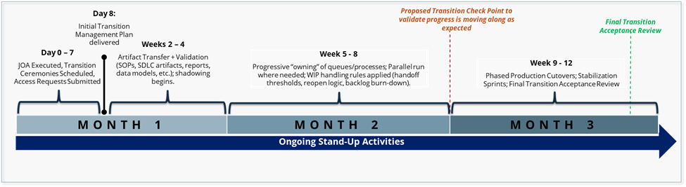

Our Successes: Deloitte's transition methodology ensures continuity of operations, minimizes risks, and achieves a smooth transfer of responsibilities within the designated timeframe. This process was successfully implemented in projects such as the Wyoming integrated eligibility application and data center transition, Texas Department of Information Resources (DIR) transitions, and California infrastructure migration to cloud operations. These experiences inform our approach, emphasizing rigorous entry and exit criteria for each phase, feedback loops, and constant risk evaluation.
Potential Roadblocks: We will support CMS through a disciplined, low-risk Transition-In approach designed to protect continuity of operations, accelerate transfer of responsibility, and maintain compliance from Day 1.
Table 2.1.3-2. Approach Summary.
Challenge | Mitigation Strategy
Compressed Start-Up Timeline & Dual-Ops Coordination  The JOA must be executed within 7 calendar days and an integrated Transition Plan delivered within 8 business days, while simultaneously managing workload with the incumbent under active dual-ops. Delays in the incumbent's JOA response or misaligned "rules of the road" can cascade into schedule and service disruptions. | Deloitte will pre-stage a Day 0–7 "JOA-ready" package including redlines, roles, single-intake workflow, WIP ownership rules, and escalation paths. A Day 1 critical-path and timeline realism check will validate dependencies and COR decision points, enabling JOA execution on time even if the incumbent is delayed. Daily transition governance, a RAID log, and a decision log aligned to the PIOP will maintain continuity throughout.
Incomplete or Uneven Transfer of In-Flight Work and Artifacts  The SOW requires the incumbent to hand over a broad set of work products (SDLC artifacts, SOPs, reports, data models, test cases). Documentation gaps, unclear WIP ownership, or version mismatches can introduce rework and cutover delays. | We will enforce a structured artifact transfer register with defined completeness criteria (minimum SDLC set, SOPs, reports, test assets) and version control. Structured KT and shadow ops will validate transfer quality, while JOA-defined owner-of-record rules, freeze windows, and parallel-run exit criteria will prevent duplication and rework prior to each phased cutover.
Security, ATO, and Sensitive-Asset Inventory Constraints  Transition activities must address PII, GFE, and GFI inventories alongside stringent FedRAMP/A&A and ATO obligations — including POA&M tracking, scanning, configuration baselines, and access onboarding (HSPD-12/PIV) — which can become a critical-path dependency. | A dedicated security/privacy and ATO workstream will be established on Day 1 to baseline PII, GFE, and GFI inventories, map access and approval dependencies as critical-path items, and maintain A&A/FedRAMP-aligned controls with continuous monitoring and POA&M discipline. Production cutovers will only proceed after security readiness gates are met.
Stakeholder Alignment and Incumbent Cooperation  A successful transition depends on sustained cooperation from the incumbent contractor — timely artifact handover, responsive KT participation, and adherence to JOA protocols. Adversarial dynamics or disengagement can stall knowledge transfer and create gaps in operational continuity. | We will establish a structured cadence of transition standups and COR touchpoints from Day 1, with escalation paths codified in the JOA. Milestone dashboards and RAID logs will provide COR visibility into incumbent performance, and clear contractual obligations for artifact delivery and KT participation will be reinforced through COR-approved acceptance criteria.

2.2 Sub-Section 2B: Quality Assurance Approach (3 Pages)
Performance Management and Quality Control Methodologies and Approach
Quality assurance for ER&R is governed by the Service Level Agreements in SOW Tables 3 and 4, the Acceptable Quality Levels (AQLs) and Key Performance Indicators (KPIs) developed under SOW §3.9, and a Quality Assurance Surveillance Plan (QASP) that Deloitte will deliver within 45 days of the start of the base period. Deloitte's quality model is designed around three operating commitments. First, every quality measure ties directly to an SOW SLA, an AQL the contract obligates Deloitte to meet, or a KPI tied to a measurable program outcome — not to abstract maturity-model citations. Second, quality is built into execution rather than inspected at the end: every dispute, casework determination, FFE update, notice generation, and call interaction passes through pre-defined quality controls before it reaches CMS or a consumer. Third, quality findings drive process and SOP changes within a defined turnaround, so the same defect does not surface twice.
Performance Controls and Monitoring Techniques
Performance is monitored continuously through a layered control architecture. Real-time operational dashboards in CERRS, HICS, SEED, and EDA CORE expose case status, dispute aging, SLA clock position, BUU cycle progress, notice generation pipeline state, call abandonment rate, voicemail age, and 834 ingestion job health to both Deloitte operations leadership and the COR. A daily operations stand-up reviews open SLA-at-risk cases, dispute trend anomalies, and any cross-task issue identified through the weekly cross-task data share described in Section 1B. Weekly Deloitte-CMS performance reviews summarize prior-week performance against every SOW SLA and AQL, surface root cause for any deviation, and document corrective action with a closure date. Monthly executive performance reporting feeds the Monthly Progress, Data and Cost Report, and quarterly portfolio reviews surface multi-month trends that warrant SOP, training, or staffing-model adjustments.
Quality Control Governance and Accountability
Deloitte's Quality Oversight Lead, accountable directly to the Project Director and reporting independently to the COR on quality matters, owns the QC program. Day-to-day QC operates with separation of duties — caseworkers do not review their own work; supervisors review against published QC checklists; an independent QA team samples closed cases at rates calibrated to risk (elevated sampling for APTC determinations, retroactive adjustments, manual overrides, and any case involving CMS-directed VIP escalation). Every deliverable carries a documented QC sign-off before submission, with the reviewer name, review date, and any discrepancy log retained for audit. QC accountability is reinforced through performance metrics built into supervisor and lead role descriptions and through the SBLO governance applied to subcontractor work.
Acceptable Quality Levels (AQLs)
Deloitte will meet or exceed every AQL defined in the SOW, including the explicit Service Level Agreements: 95% of high-complexity issuer disputes resolved within 10 business days (SOW Table 3); 100% of low-complexity Form 1095-A consumer disputes resolved within 2 business days; 100% of medium-complexity 1095-A disputes resolved within 5 business days; and 100% of high-complexity 1095-A disputes resolved within 10 business days (SOW Table 4). Additional AQLs developed jointly with CMS during the QASP finalization will cover deliverable acceptance (clarity, accuracy, timeliness, completeness), call center performance (speed of answer, abandonment, voicemail one-business-day response), notice generation pipeline accuracy and translation compliance, FFE update precision (zero sequencing errors per BUU cycle), and reporting timeliness (Monthly Progress, Data and Cost Report by the third Monday). Where ambiguity exists at the start of the base period, Deloitte will confirm AQLs with CMS during PIOP review rather than operate against an unverified standard.
Contractor Performance Analysis
Deloitte will operate a structured performance self-assessment that runs in parallel with CMS oversight, not as a substitute for it. Each month, Deloitte's Quality Oversight Lead produces a self-assessment scorecard that grades performance against every published SLA, AQL, and KPI, identifies trend lines, and proposes any needed corrective action — submitted to the COR alongside the Monthly Progress, Data and Cost Report. This self-assessment is independent of operational reporting from caseworkers and supervisors and is the primary input to the quarterly performance trend review with CMS. The output also feeds Deloitte's Contractor Performance Assessment Reporting System (CPARS) input.
Performance Reporting
Deloitte will deliver three monthly QA-related reports per SOW §3.9 (Quality Assurance Report, Monthly Performance Report, Business Process Improvement Report) and integrate performance data into the Monthly Progress, Data and Cost Report. Each QA report includes a forward-looking corrective action plan rather than a backward-looking metric dump: every defect, missed AQL, or trend deviation is paired with a root-cause hypothesis, a corrective action, an owner, and a closure date. Where Deloitte recommends a corrective action plan that requires CMS approval, that recommendation is brought forward in writing in the same reporting cycle the issue is observed.
Performance Correction Mechanisms
Deloitte applies a tiered correction model. Tier 1 (operational): caseworker-level errors are corrected by the caseworker, peer-reviewed by a supervisor, and logged for trend analysis. Tier 2 (process): repeated errors of the same type trigger an SOP review, a targeted training refresh, and a 30-day monitoring window before the action closes. Tier 3 (program): a missed AQL or a systemic trend triggers a formal Corrective Action Plan submitted to the COR within 5 business days of identification, including root cause analysis, remediation milestones, performance metrics demonstrating recovery, and a structured close-out review. Corrective actions are tracked to closure in the integrated RAID log, with monthly status visible to the COR.
Performance Metrics and Key Performance Indicators (KPIs)
KPIs are derived from the SOW §3.9 data collection and analysis elements (a) entity submission types, (b) enrollee data accuracy, (c) reason codes, (d) effective dates, (e) terminations, (f) cancellations, (g) plan-level accuracy, (h) APTC/CSR validations, (i) ASC X12N 834/820 transaction reconciliation, (j) error reports, (k) error correction, (l) error reporting, (m) trending analysis of reconciliation, (n) source/content of common inquiries, (o) vulnerability identification, and (p) additional CMS-identified elements. The Performance Measurement Plan in this volume aligns each of these elements to a measurable KPI with a numeric target, a monitoring cadence, and an early-warning threshold. KPI definitions are presented to the COR for refinement and approval at the business process improvement kick-off and reported monthly thereafter through the Monthly Performance Report.
Service Level Agreements (SLAs)
SLA management is operated as a continuous control function rather than a periodic review. Every case, dispute, deliverable, and call has its SLA clock started at intake — automatically in CERRS, HICS, and SEED for system-tracked items, and through the operational dashboard for non-system-tracked items. An SLA Risk Engine triggers supervisor intervention when any case crosses 70% of its allowed window, before the SLA itself is breached. SLA performance is reviewed daily at the operations stand-up and weekly at the Deloitte-CMS performance review, with any breach pattern triggering the Tier 3 Corrective Action Plan described above. SLA reporting follows the SOW deliverables schedule with daily, weekly, and monthly cadences as defined per task.
QASP alignment to SLAs, AQLs, KPIs and Escalation Mechanisms
Deloitte will deliver a draft Quality Assurance Surveillance Plan (QASP) within 45 days of the start of the base period per SOW §3.9, jointly review and finalize the QASP with the COR within 30 days of that review, and store the approved QASP in a CMS-approved location with version control. The QASP defines, for every SOW SLA and AQL: the measurement method, the data source, the responsible owner, the reporting cadence, the acceptable performance threshold, and the escalation mechanism for non-conformance. QASP updates follow PIOP change-control discipline and are submitted to CMS for review and approval whenever a PWS change, regulatory update, or COR direction warrants revision. The QASP is the single instrument linking Deloitte's performance to CPARS — making the relationship between day-to-day execution and downstream contractor evaluation transparent and verifiable.

2.3 Sub-Section 2C: Staffing Plan (2 Pages)
Workforce Delivering the SOW Tasks and Requirements
Deloitte's staffing model responds to a single operating reality: ER&R workload is concentrated, seasonal, and risk-sensitive. The staffing footprint at contract start is sized to deliver continuity across all ten SOW tasks from Day 1, scaled in proportion to the workload drivers (issuer disputes, 1095-A casework, CCHC, IT systems O&M, and contact center support), and structured to flex up for tax season and Open Enrollment surge without disrupting steady-state operations. The workforce is organized into five integrated delivery towers — Business Operations, Technology Management, Program Management & Program Controls, Quality Assurance / SOP / Knowledge Management, and SME / Program Integrity — staffed with a labor mix of senior leadership, mid-level operational analysts, junior caseworkers, and subject matter experts proportioned to the actual case complexity each tower handles. Prime and subcontractor personnel operate as one integrated delivery workforce under unified Deloitte governance, with subcontractor work governed by the same SLAs, AQLs, and QA standards described in Sub-Section 2B. The detailed organizational chart is provided in Figure 2.3-1; the labor mix matrix by labor category, task, and sub-task is provided in Volume II: Business Quote per the Attachment 2 pricing template instructions.
Figure 2.3-1. Organizational Chart.
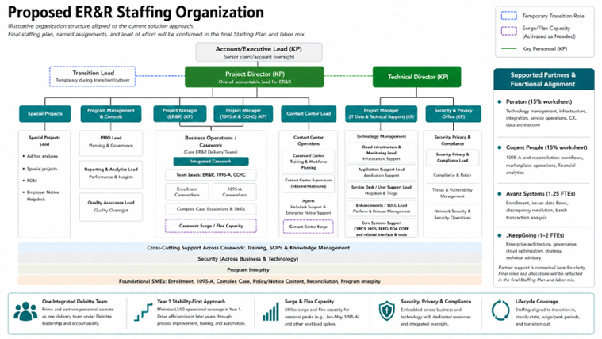
Resource Management and Staffing Approach
Deloitte's resource management approach is built around five operating commitments. First, role-based assignment: every caseworker, analyst, engineer, and supervisor is matched to a specific function within a specific tower, with documented role descriptions, competency requirements, and SOW-task accountability — eliminating the under-specified "generalist" model that creates SLA risk in casework operations. Second, lifecycle-aware staffing: the model phases through transition-in (months 1-3 emphasizing knowledge transfer, system access, and shadow operations), steady-state operations (months 4+ optimized for SLA performance and continuous improvement), peak periods (tax season and post-Open-Enrollment ramp), and transition-out (orderly turnover) — with explicit headcount and skill-mix requirements at each phase. Third, recruitment and retention discipline: Deloitte's CMS Marketplace recruiting bench, refreshed continuously and pre-cleared for federal background investigation processing, sources permanent staff with prior FFE/SBE experience and SOW-relevant federal healthcare data system experience. Fourth, integrated workforce management: prime and subcontractor staff operate as one team with shared training, shared QA standards, shared performance metrics, and a single Project Director accountable for total workforce performance. Fifth, transparent staffing visibility: the COR has continuous access to staffing levels by tower and task through the operations dashboard, with formal reporting via the Monthly Progress, Data and Cost Report and any staffing change of consequence flagged for COR concurrence in advance per SOW §3.1.
[Deloitte to populate: detailed labor-mix matrix showing FTE counts by labor category by task / sub-task across the base period and four option periods, separated by prime and proposed subcontractors with current-on-staff vs. proposed-new flagged. Final matrix appears in Volume II: Business Quote per Attachment 2 pricing template; this volume references that matrix.]
Surge Support
Form 1095-A consumer dispute volume triples between December and February and remains elevated through May (SOW assumptions, monthly volumes table). Deloitte's surge plan responds to that exact curve. Recruiting begins in early November for the temporary case analyst pool sized to the SOW assumption of approximately 100-120 temporary analysts and 4 temporary team leads. CMS background investigations begin at offer acceptance to ensure the first wave is cleared, system-trained, and shadow-certified before January 1. A returner-first model preferentially re-engages prior-season caseworkers — they skip baseline training, complete a policy update refresher, and reach full productivity from their first day back. New hires train on prior-year root-cause case types under peer certification by returners before touching a live case. Additional waves deploy in late January and February as volume climbs toward the February peak. The pool is released in phases beginning in May and concluding by early July as volumes return to baseline. Casework surge (queue balancing, backlog absorption, escalation coverage, complex-case overflow) and contact center surge (call coverage, voicemail response, supervisor-to-agent ratio maintenance) are managed as distinct operating disciplines so peak coverage in one channel does not degrade quality in another. Surge personnel receive role-based access to CERRS, HICS, and SEED with the same security controls, audit logging, and field-level masking that apply to permanent staff.
Technical surge capacity is maintained in parallel. During Open Enrollment, the EDA CORE 834 ingestion pipeline processes thousands of transactions per hour; Deloitte pre-positions Snowflake performance-tuning capacity, on-call DevOps coverage, and incident response staffing at heightened readiness. Service desk Tier 2 and Tier 3 capacity flexes through a defined reserve pool that activates on threshold rather than after backlog accumulation. Release cadence and Change Control Board scheduling respect the SOW-required software-integration lockout windows during Open Enrollment so technical change does not introduce risk during the highest-stakes period of the year.

3.0 Section 3: Key Personnel Qualifications and Corporate Experience (Total 8 Pages)

3.1 Sub-Section 3A: Key Personnel Qualifications (4 Pages)
Key Personnel Roles and Responsibilities
Deloitte has assembled a proven leadership team with deep, direct experience supporting CMS Marketplace operations, enrollment reconciliation, and federal healthcare data systems. Each proposed key personnel member brings specific, hands-on experience directly aligned to the requirements of this SOW. Our team is ready to lead from day one, ensuring continuity, accountability, and expert execution across all ER&R tasks.
The following individuals are designated as Key Personnel for this task order. Current resumes are in Appendix A.
Table 3.1-1. Key Personnel – Education, Professional Experience, & Availability
Personnel, Education & Availability | Professional Experience & Qualifications
[FIRST LAST, Degrees]
Project Director
(Key Personnel)
[X]% | Base Period – OP4
[Degree, Field] [University Name]
[FIRST LAST, PMP]
Project Manager (ER&R)
(Key Personnel)
[X]% | Base Period – OP4
[Degree, Field] [University Name]
[FIRST LAST, PMP]
Project Manager (Form 1095-A & CCHC)
(Key Personnel)
[X]% | Base Period – OP4
[Degree, Field] [University Name]
[FIRST LAST, Degrees]
Project Manager (IT Data & Technical Support)
(Key Personnel)
[X]% | Base Period – OP4
[Degree, Field] [University Name]
[FIRST LAST, Degrees]
Technical Director
(Key Personnel)
[X]% | Base Period – OP4
[Degree, Field] [University Name]
[FIRST LAST, CISSP]
Security & Privacy Officer
(Key Personnel)
[X]% | Base Period – OP4
[Degree] [University Name]

Significant Leads and Responsibilities
In addition to designated Key Personnel, Deloitte will leverage the expertise of the following significant leads who play critical roles in delivering SOW requirements. These individuals bring deep subject matter expertise and will be actively engaged throughout the contract period.
Table 3.1-2. Significant Leads — Roles, Qualifications & Availability.
Personnel, Education & Availability | Professional Experience & Qualifications
[FIRST LAST, Degrees]
Program Integrity Lead
[X]% | Base Period – OP4
[Degree, Field] [University Name]
[FIRST LAST, Degrees]
Call Center Lead
[X]% | Base Period – OP4
[Degree, Field] [University Name]
[FIRST LAST, Degrees]
[Lead Title/Role — PLACEHOLDER]
[X]% | Base Period – OP4
[Degree, Field] [University Name]
[FIRST LAST, Degrees]
[Lead Title/Role — PLACEHOLDER]
[X]% | Base Period – OP4
[Degree, Field] [University Name]
[FIRST LAST, Degrees]
[Lead Title/Role — PLACEHOLDER]
[X]% | Base Period – OP4
[Degree, Field] [University Name]

Retention and Replacement Approach
Retaining qualified key personnel is critical to uninterrupted ER&R program operations. Deloitte has institutionalized robust succession processes to minimize disruption in the event of departures:
- Pre-qualified bench of successors: Deloitte maintains a pipeline of CMS-experienced professionals for each key position. At least one qualified backup candidate has been identified in advance for each key role.
- Living transition documentation: All key personnel maintain current documentation of responsibilities, ongoing deliverables, CMS relationships, and open case status, enabling rapid knowledge transfer.
- COR notification and prior approval: Any key personnel substitution will be promptly communicated to the COR. Proposed replacements will meet or exceed all minimum qualifications for the position prior to assuming responsibilities.
- Transition overlap period: Where advance notice is available, Deloitte ensures a minimum 30-day co-performance period so outgoing and incoming personnel work in parallel, preserving operational continuity and institutional knowledge.
Level of Effort

3.2 Sub-Section 3B: Corporate Experience (4 Pages)
We understand why change feels risky. Transition issues, delayed eligibility determinations, or call center disruptions can mean consumers can't get answers about their health coverage, benefits, or enrollment status. Legislative and public scrutiny leaves no margin for disruption. But continuity and change are not mutually exclusive. Deloitte has the experience, methodology, and proven track record to make change invisible to the consumer, protecting consumer experience while modernizing the systems underneath it.
Table 3.2-1. Corporate Experience Matrix
Project Name & Client / Agency | Period of Performance | Project Description & Relevance to SOW | ER&R Issuer Disputes | 1095-A Consumer Disputes | IT Systems O&M | Data Analytics & BI Reporting |  | Contact Center Support |  | Security & Compliance |  | Eligibility & Enrollment Systems |  | Healthcare Exchange Platform Dev & Ops
XX / U.S. Office of Personnel Management (OPM) | Aug 2023 – Aug 2025 | Deloitte delivers and operates a large-scale federal health benefits enrollment platform supporting 1.9 million USPS employees and retirees across 17 carriers and 69 plan options. The platform is available 24/7 and serves as the authoritative system for enrollment, eligibility, and benefits management for one of the largest employer-sponsored health programs in the federal government. Deloitte provides system development, maintenance, and operations services, including automated fraud, waste, and abuse detection controls projected to save $3 billion annually, demonstrating automation-first processing capability in a complex, highly regulated environment.  Size: Federal; $175M contract value  Scope: Full platform delivery and operations, including maintenance of 8 integrated applications and 20 interfaces, member record management, carrier and plan administration across 17 carriers and 69 plan options, and automated FWA detection and controls.  Complexity: 8 Applications, 20 External Interfaces, 1.9M Members, 113M+ Annual Transactions, peak single-hour active user count of 4,690, migration of 2.25 million member records at 99.6% accuracy  Technological Landscape: Azure FedRAMP Commercial Cloud, API integration (average response time 0.255 seconds against a 2-second SLA), NIST 800-53 compliance, FedRAMP authorization, automated FWA detection controls
Department of State, Bureau of Consular Affairs (CA) | Sep 2019 – Sep 2026 | Deloitte provides operations, maintenance, and modernization support for 80+ mission-critical applications across 240+ global posts, resolving 21K+ tickets annually under a 24/7/365 operational support model with 200+ deployments managed annually using Agile principles. The engagement encompasses system operations, software development, Tier III production support, and mission-critical system transitions from incumbent vendors, demonstrating Deloitte's ability to manage large-scale federal IT portfolios under demanding service-level and compliance requirements.  Size: Federal; $430M projected contract value  Scope: Operations, maintenance, and modernization of 80+ mission-critical applications. Scope includes system operations, software development, Tier III production support, DevSecOps delivery, and mission-critical system transitions.  Complexity: 80+ applications, 240+ global posts, 21K+ tickets annually, 200+ deployments per year, geographically dispersed multi-system environment, FISMA Moderate compliance  Technological Landscape: FISMA Moderate, DevSecOps, Agile delivery, continuous deployment pipelines
State of Washington | Apr 2012 – Jun 2028 | Deloitte provides continuous 24/7 O&M support for a fully functional state-based exchange (SBE) supporting 1.5 million Medicaid enrollees, maintaining 99.9% high availability and deploying major enhancement releases every six weeks. The engagement scope mirrors the FFE including eligibility, enrollment, interfaces, correspondence, plan management, administration, reporting, and Form 1095-A generation and validation delivered directly to consumers.  Size: State; $196.5M contract value  Scope: Full O&M support for state-based exchange including eligibility, enrollment, interfaces, correspondence, plan management, administration, reporting, and Form 1095-A generation.  Complexity: 1.5M Medicaid enrollees, 99.9% availability SLA, bi-weekly release cadences, cyclical Open Enrollment peak demand, multi-stakeholder coordination across state and federal entities  Technological Landscape: FedRAMP Moderate, public-facing health insurance exchange environment
California Healthcare Eligibility, Enrollment, and Retention System (CalHEERS) / State of California | Sep 2019 – Jun 2027 | CalHEERS is a critical public-facing platform available to all 39 million Californians 24/7 to search, compare, and access affordable health care options that meet their unique health care needs. CalHEERS provides functionality to support a multitude of programs related to health care enrollment, including eligibility, plan preview and selection, and ongoing retention including management of available health care plans and affordability options. Deloitte serves as the System Integrator (SI) vendor for CalHEERS and provides system development, maintenance, and operations (SDMO) services. Deloitte modernized CalHEERS to support over 55 million daily transactions and over 36,000 daily users on average during OE periods, serving 149,000 user visits and 112 million transactions per day at peak OE. Deloitte has also transitioned CalHEERS to a modernized cloud data and analytics platform capable of tackling complex business questions related to eligibility analytics, enrollment analytics, plan choice analytics, and transition analytics.  Size: State; $900+ million, 7-year program, 800+ FTEs  Scope: Deloitte serves as the System Integrator (SI) vendor for CalHEERS and provides system development, maintenance, and operations (SDMO) services. Deloitte also provides enhancements, security, maintenance, subcontractor, and product vendor management, 24/7 help desk support, and ongoing operations of core applications.  Complexity: 10 Applications (2 COTS), 41 External Systems (30 Real Time), 7.7M Users, Multiple locations, working with 10+ contractors, supporting 100+ SW products across vendors in this multi-vendor environment  Technological Landscape: Microservice architecture, Java, OpenShift, Aurora PostgresSQL, Oracle, Amazon Web Services (AWS) – Amazon EC2, AWS Snowball, Amazon S3, Amazon EBS, Amazon EFS, AWS Direct Connect, Salesforce, GitLab, SonarQube, Splunk, Jenkins, Selenium, Dynatrace, LoadRunner, Snowflake, Tableau Server, Autosys, Databricks, PySpark Data Lake Builder
Veteran Benefits Administration / VA Medical Disability Examination (MDE) | Oct 2024 – Dec 2026 | Cogent serves as the prime contractor on CMS's PPFMG Financial Management Operational Analytics (FMOA) program, a mission-critical Marketplace platform supporting issuer payment validation, reconciliation, and financial data integrity across systems that directly interface with ER&R and the Federally Facilitated Exchange (FFE). The program requires deep knowledge of CMS/CCIIO operations, regulatory compliance, and the complex financial and enrollment data flows that underpin the Marketplace. Cogent has supported CMS and CCIIO continuously since 2009, bringing institutional knowledge of core Marketplace platforms and the financial management processes that directly align with ER&R operational requirements.  Size: Federal; $31M contract value  Scope: IT consulting, business consulting, software engineering, data analytics, program management, data strategy, and architecture integration. Scope includes issuer payment validation, reconciliation analytics, dispute resolution, 1095-A processing, root cause analysis, and rules automation across core Marketplace platforms.  Complexity: Multi-system integration environment spanning DSH, MSI, MIDCAP, MIDAS, ES, FFE, ER&R, and FFE interfaces; audit readiness and ongoing operational support across financial and enrollment data streams; continuous CMS/CCIIO engagement since 2009 across multiple program iterations  Technological Landscape: CMS Marketplace platforms (DSH, MSI, MIDCAP, MIDAS, ES, FFE), ER&R and FFE system interfaces, reconciliation analytics, rules automation, financial data integrity controls, enrollment reconciliation architecture
Veteran Health Administration / VA Connect | Jun 2022 – Sep 2024
Financial Management Operational Analytics (FMOA) / CCIIO
Project name / Client | MM/YYYY – MM/YYYY | Project Description: Cogent Project 2  Size:  Scope:  Complexity:  Technological Landscape:
Project name / Client | MM/YYYY – MM/YYYY | Project Description: Peraton Project 1  Size:  Scope:  Complexity:  Technological Landscape:
Project name / Client | MM/YYYY – MM/YYYY | Project Description: Peraton Project 2  Size:  Scope:  Complexity:  Technological Landscape:

The experience matrix that follows demonstrates exactly that. Deloitte has successfully transitioned 40+ large, complex systems, including six State-Based Exchanges, without downtime or negative impacts to user access. We hold the only other federal exchange contract, operate large-volume call centers receiving upwards of 55,000 contacts per week, and have surged 900 staff in three days to meet emergency demand. We develop 1095-A forms for state-based exchanges including Covered California, delivering over 1.5 million forms last year with a dispute rate of just 0.20% far outperforming industry baselines. We have deep FFE expertise, including former CCIIO leaders, and work regularly to reconcile enrollment and exchange data across five state-based exchanges.

4.0 Section 4: Small Business Utilization (5 Pages)

4.1 Approach to Maximize Small Business Subcontracting
Deloitte's small business plan is built around the RFQ goal of 15% of total task order dollars subcontracted to small business and reflects how Deloitte has consistently exceeded small business utilization targets on comparable federal task orders. Deloitte will exceed the 15% goal across the base period and every option period through a combination of direct subcontracting, teaming arrangements, and targeted small-business sourcing across the labor categories that drive ER&R operational delivery — issuer dispute analytics, 1095-A casework surge, IT systems engineering, contact center support, and quality assurance.
Deloitte's small business strategy is anchored to four operating principles. First, small businesses are integrated as full delivery partners, not pass-through capacity, with named workshare on specific SOW tasks and accountability tied to the same SLAs and quality standards that govern Deloitte's prime work. Second, small business utilization is maintained year-over-year through structured workshare commitments that flex with workload (1095-A surge, OE peak, ad hoc projects under Task 10) so small business teaming partners are not crowded out as the program scales. Third, small business performance is tracked and reported monthly to the COR with the same rigor Deloitte applies to its own performance — utilization percentage, deliverable quality, schedule adherence, and corrective action where needed. Fourth, Deloitte's Small Business Liaison Officer (SBLO) is the single point of accountability for plan execution, COR reporting, and continuous identification of new small business opportunities throughout the period of performance.
4.2 Proposed Small Business Subcontractors
The table below identifies Deloitte's proposed small business subcontractors, the work each will perform, and the proportion of total task order value committed to each. Letters of commitment and draft subcontracting agreements are provided as attachments outside the page count, in accordance with the RFQ instructions.
Table 4.2-1. Proposed Small Business Subcontractors.
[Deloitte to populate: Subcontractor Name | Address | POC and Phone | NAICS / Size / Socioeconomic Status (e.g., 8(a), HUBZone, SDVOSB, WOSB, EDWOSB, Small Disadvantaged Business) | Work to be Performed | Proportion of Total Contract Value (%) | Total $ Proposed — for each proposed small business subcontractor, formatted per Attachment 2 instructions.]
4.3 Commitment to Use Small Businesses
Deloitte's commitment to small business participation is documented through three concrete instruments included with this quote as attachments and not counted against the Volume I page limit:
- Signed letters of commitment from each proposed small business subcontractor confirming availability, proposed labor categories, and willingness to perform the workshare described in Table 4.2-1.
- Draft subcontracting agreements outlining scope, performance standards, flow-down clauses (FAR/HHSAR/CMS-specific privacy and security clauses, Section 508, and the Conflict of Interest CMS clause), termination provisions, and reporting requirements.
- Teaming arrangement narratives describing prior Deloitte experience with each proposed small business — including projects delivered jointly, integration history, and small business performance outcomes — so CMS has a verifiable basis to assess the credibility of each commitment.
All proposed small business subcontractors will receive the same flow-down requirements that apply to Deloitte under the prime contract, including FAR Subpart 8.4, HHSAR clauses, the CMS Conflict of Interest (AUG 2024) clause, FedRAMP and HHS information security requirements, the HHS Standard for Encryption, OMB M-17-12 breach response obligations, NIST SP 800-53 controls applicable at the moderate impact level for the FFE/SBE data, Section 508 conformance, and the Privacy Act requirements applicable to System of Records Notice 09-70-0560.
4.4 Subcontracting Plan Governance
Deloitte will deliver a Small Business Subcontracting Plan within 30 days of award (or per the timeline established by the Contracting Officer) with the elements required by FAR 19.704 and HHSAR 352.219-70, including utilization goals by socioeconomic category, plan administration, recordkeeping, equitable opportunity, and reporting (eSRS Individual and Summary Subcontract Reports). Deloitte's SBLO will:
- Track and report small business utilization monthly to the COR within the Monthly Progress, Data and Cost Report (SOW §3.1) — broken out by total dollars, labor categories, task/sub-task allocation, and socioeconomic category.
- Conduct quarterly small business performance reviews jointly with each subcontractor, surfacing ramp opportunities, risk indicators, and any need for corrective action — with results summarized to CMS.
- Identify new small business opportunities continuously throughout the period of performance — particularly within Task 10 ad hoc and special projects, where short-cycle work is well-suited to small business participation — and bring forward proposed additions to the subcontracting plan for COR concurrence.
- Document and report any planned changes to the subcontracting plan promptly, with rationale and impact analysis, so CMS retains continuous visibility into small business commitment execution.
4.5 Prime Contractor Workshare Disclosure
Deloitte Consulting LLP is a large business prime; the share-of-work narrative described above governs the small business subcontracting commitment. The proportion of work performed directly by Deloitte versus subcontractors (including any large-business teaming partners) is detailed in the labor-hour matrix submitted with Volume II: Business Quote in accordance with Attachment 2 pricing template instructions.

Appendix A Key Personnel Resumes (2 Pages Each)

A.1 Project Director
Name Legal Entity, Title
Labor Category:

Experience Summary
CALLOUT 2 BOX TITLE TEXT
Lorem ipsum dolor sit amet, consectetuer adipiscing elit. Maecenas porttitor congue massa. Fusce posuere, magna sed pulvinar ultricies, purus lectus malesuada libero, sit amet commodo magna eros quis urna.
Give a synopsis of candidate's experience with focus on relevant tasks, duties, work, accomplishments. Spell out numbers zero to nine; use numerical values for 10 and higher, unless the number represents a dollar amount (i.e., $1 Million). Also, please refer to the candidate as Title plus Last Name, for example: Ms. Smith has over 15 years of experience in financial management.
Example: Mr. Smith has more than 12 years of extensive IT experience, specializing in complex programs. He has experience with data governance, data management, meta-data management, data warehousing, data cleansing and enterprise reporting. Mr. Smith has worked in many industries and environments, including past experience working with DHS. He has a demonstrated track record of program management as well as bringing projects to closure in challenging environments.
Recent Experience
Resume Job Title Dates

Employment History
- Company, Title, (From – To)

Education
- Degree, Field, School

A.2 Project Manager (ER&R)
Name Legal Entity, Title
Labor Category:

Experience Summary
CALLOUT 2 BOX TITLE TEXT
Lorem ipsum dolor sit amet, consectetuer adipiscing elit. Maecenas porttitor congue massa. Fusce posuere, magna sed pulvinar ultricies, purus lectus malesuada libero, sit amet commodo magna eros quis urna.
Give a synopsis of candidate's experience with focus on relevant tasks, duties, work, accomplishments. Spell out numbers zero to nine; use numerical values for 10 and higher, unless the number represents a dollar amount (i.e., $1 Million). Also, please refer to the candidate as Title plus Last Name, for example: Ms. Smith has over 15 years of experience in financial management.
Example: Mr. Smith has more than 12 years of extensive IT experience, specializing in complex programs. He has experience with data governance, data management, meta-data management, data warehousing, data cleansing and enterprise reporting. Mr. Smith has worked in many industries and environments, including past experience working with DHS. He has a demonstrated track record of program management as well as bringing projects to closure in challenging environments.
Recent Experience
Resume Job Title Dates

Employment History
- Company, Title, (From – To)

Education
- Degree, Field, School

A.3 Project Manager (Form 1095-A & CCHC)
Name Legal Entity, Title
Labor Category:

Experience Summary
CALLOUT 2 BOX TITLE TEXT
Lorem ipsum dolor sit amet, consectetuer adipiscing elit. Maecenas porttitor congue massa. Fusce posuere, magna sed pulvinar ultricies, purus lectus malesuada libero, sit amet commodo magna eros quis urna.
Give a synopsis of candidate's experience with focus on relevant tasks, duties, work, accomplishments. Spell out numbers zero to nine; use numerical values for 10 and higher, unless the number represents a dollar amount (i.e., $1 Million). Also, please refer to the candidate as Title plus Last Name, for example: Ms. Smith has over 15 years of experience in financial management.
Example: Mr. Smith has more than 12 years of extensive IT experience, specializing in complex programs. He has experience with data governance, data management, meta-data management, data warehousing, data cleansing and enterprise reporting. Mr. Smith has worked in many industries and environments, including past experience working with DHS. He has a demonstrated track record of program management as well as bringing projects to closure in challenging environments.
Recent Experience
Resume Job Title Dates

Employment History
- Company, Title, (From – To)

Education
- Degree, Field, School

A.4 Project Manager (IT Data and Technical Support)
Name Legal Entity, Title
Labor Category:

Experience Summary
CALLOUT 2 BOX TITLE TEXT
Lorem ipsum dolor sit amet, consectetuer adipiscing elit. Maecenas porttitor congue massa. Fusce posuere, magna sed pulvinar ultricies, purus lectus malesuada libero, sit amet commodo magna eros quis urna.
Give a synopsis of candidate's experience with focus on relevant tasks, duties, work, accomplishments. Spell out numbers zero to nine; use numerical values for 10 and higher, unless the number represents a dollar amount (i.e., $1 Million). Also, please refer to the candidate as Title plus Last Name, for example: Ms. Smith has over 15 years of experience in financial management.
Example: Mr. Smith has more than 12 years of extensive IT experience, specializing in complex programs. He has experience with data governance, data management, meta-data management, data warehousing, data cleansing and enterprise reporting. Mr. Smith has worked in many industries and environments, including past experience working with DHS. He has a demonstrated track record of program management as well as bringing projects to closure in challenging environments.
Recent Experience
Resume Job Title Dates

Employment History
- Company, Title, (From – To)

Education
- Degree, Field, School

A.5 Technical Director
Name Legal Entity, Title
Labor Category:

Experience Summary
CALLOUT 2 BOX TITLE TEXT
Lorem ipsum dolor sit amet, consectetuer adipiscing elit. Maecenas porttitor congue massa. Fusce posuere, magna sed pulvinar ultricies, purus lectus malesuada libero, sit amet commodo magna eros quis urna.
Give a synopsis of candidate's experience with focus on relevant tasks, duties, work, accomplishments. Spell out numbers zero to nine; use numerical values for 10 and higher, unless the number represents a dollar amount (i.e., $1 Million). Also, please refer to the candidate as Title plus Last Name, for example: Ms. Smith has over 15 years of experience in financial management.
Example: Mr. Smith has more than 12 years of extensive IT experience, specializing in complex programs. He has experience with data governance, data management, meta-data management, data warehousing, data cleansing and enterprise reporting. Mr. Smith has worked in many industries and environments, including past experience working with DHS. He has a demonstrated track record of program management as well as bringing projects to closure in challenging environments.
Recent Experience
Resume Job Title Dates

Employment History
- Company, Title, (From – To)

Education
- Degree, Field, School

A.6 Security and Privacy Officer
Name Legal Entity, Title
Labor Category:

Experience Summary
CALLOUT 2 BOX TITLE TEXT
Lorem ipsum dolor sit amet, consectetuer adipiscing elit. Maecenas porttitor congue massa. Fusce posuere, magna sed pulvinar ultricies, purus lectus malesuada libero, sit amet commodo magna eros quis urna.
Give a synopsis of candidate's experience with focus on relevant tasks, duties, work, accomplishments. Spell out numbers zero to nine; use numerical values for 10 and higher, unless the number represents a dollar amount (i.e., $1 Million). Also, please refer to the candidate as Title plus Last Name, for example: Ms. Smith has over 15 years of experience in financial management.
Example: Mr. Smith has more than 12 years of extensive IT experience, specializing in complex programs. He has experience with data governance, data management, meta-data management, data warehousing, data cleansing and enterprise reporting. Mr. Smith has worked in many industries and environments, including past experience working with DHS. He has a demonstrated track record of program management as well as bringing projects to closure in challenging environments.
Recent Experience
Resume Job Title Dates

Employment History
- Company, Title, (From – To)

Education
- Degree, Field, School
Callout 1 Title
Callout2 Body
- Callout2 Checkmark Bullet
- Callout2 Bullet
- Callout2 Bullet2
CALLOUT 2 BOX TITLE TEXT
Lorem ipsum dolor sit amet, consectetuer adipiscing elit. Maecenas porttitor congue massa. Fusce posuere, magna sed pulvinar ultricies, purus lectus malesuada libero, sit amet commodo magna eros quis urna.
Callout 3 Box  Title Text | Lorem ipsum dolor sit amet, consectetuer adipiscing elit. Maecenas porttitor congue massa. Fusce posuere, magna sed pulvinar ultricies, purus lectus malesuada libero, sit amet commodo magna eros quis urna.
Figure X.X-X. Provide Title.
Action caption, if needed
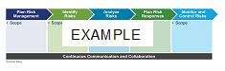
Table Heading | Table Heading | Table Heading | Table Heading
Table Row Heading | Table body | Table Column Heading | - Table Checkmark
 | - Table Bullet 1 | Table Body Centered
 | - Table Bullet 2
 | Table Bullet 3

Name Legal Entity, Title
Proposed Project Role: Title

Experience Summary
CALLOUT 2 BOX TITLE TEXT
Lorem ipsum dolor sit amet, consectetuer adipiscing elit. Maecenas porttitor congue massa. Fusce posuere, magna sed pulvinar ultricies, purus lectus malesuada libero, sit amet commodo magna eros quis urna.
Give a synopsis of candidate's experience with focus on relevant tasks, duties, work, accomplishments. Spell out numbers zero to nine; use numerical values for 10 and higher, unless the number represents a dollar amount (i.e., $1 Million). Also, please refer to the candidate as Title plus Last Name, for example: Ms. Smith has over 15 years of experience in financial management.
Example: Mr. Smith has more than 12 years of extensive IT experience, specializing in complex programs. He has experience with data governance, data management, meta-data management, data warehousing, data cleansing and enterprise reporting. Mr. Smith has worked in many industries and environments, including past experience working with DHS. He has a demonstrated track record of program management as well as bringing projects to closure in challenging environments.
Recent Experience
Resume Job Title Dates

Employment History
- Company, Title, (From – To)

Education
- Degree, Field, School

Past Performance1-Paragraph
Offeror | Deloitte |  | Client | Name of Agency, Company, or Organization
Project Name
Contract Number(s): |  |  |  | Value of Contract:
Contract Type: |  | e.g., T&M, FFP |  | Period of Performance: | MM/YYYY – MM/YYYY
Client Point of Contact: |  | Name ,Agency, Phone, Number, Email Address

Relevance to Agency Name:
Describe in a few bullets the relevance of the project to the opportunity. See generic examples below.
- (Example A) Relevance to Agency Name:
- Large-scale project with significant financial, reporting, and management implications.
- COTS implementation; replacement of legacy systems.
- BPA with multiple task orders, similar to an IDIQ contract.
- (Example B) Relevance to Agency Name:
- [Industry name] project with performance, reporting, and maintenance aspects.
- Similar organizational, technical, and operational requirements.
- COTS integration solution.
Narrative:
Description of work performed—briefly outlining the client’s challenge/situation and what you were hired to do. Please describe the scope of the project, noting broad similarities with Agency Name activity requirements. Describe magnitude in terms of dollar amounts, number of personnel fielded, etc. Describe the project’s complexity in reference to Agency Name or task order requirements and similarities of work performed. Note things delivered, results provided, etc.
(Example A) The ABC project encompasses a wide range of activities, from documentation and user/data requirements tasks to deployment and training. The project’s scope is comparable to Agency Name IDIQ requirements, with similar staffing and technical needs and a similar management methodology used. The ABC project has involved multiple sites and approximately 120 Deloitte team members at peak; it will affect some 6,000 users at full deployment.
Similar to Agency Name requirements, the project includes a variety of planning, design, development, and integration activities. Work has been performed under a blanket purchase agreement (BPA) with multiple delivery orders. The Deloitte team worked closely with Agency Name management to build support for the implementation and develop a communications strategy for informing employees about the upcoming transition and provide specialized instruction and support for staff in new roles. As the lead systems integrator and program manager, the Deloitte team was responsible for the following:
- Establishing a program governance process and developing a program management office to coordinate this large-scale Oracle roll-out.
- Developing and deploying the Oracle-based system at client locations, including replacing and retiring legacy financial systems.
(Example B) Support of the Agency Name included a variety of activities similar to Agency Name Task Order Name requirements. This $15 million, multi-year project covers both agency and enterprise-wide technology and management issues.
- The development and implementation of a COTS-based solution during this project is comparable to activities described in the Agency Name RFP. Deloitte developed and deployed a Microsoft Project Server, Web-based tool (Tool Name). The Deloitte team adapted and enhanced the tool to support program plan management and collaboration in accordance with requirements provided by the X Business Unit. The team provides advice and planning on communications and audit strategy, analyzes plan thoroughness and feasibility, and assists in content development for best practices guides and methodologies. Deloitte supports compliance efforts to implement methodology for management in assessment, documentation, and reporting on the internal controls over financial reporting. Additional actions and results:
- Bullet 1 text.
- Bullet 2 text.
- Etc.
Solution Benefits:
Short description, in bullets, describing benefits provided. Please try to provide hard evidence of measurable results—e.g., saved $X, reduced errors Y percent, increased efficiency Z percent, etc. See example below.
(Example) In addition to the engagement goals, the client has benefited from the project by:
- Eliminating redundant and outdated financial systems.
- Implementing a centralized financial platform, which increases compliance with federal accounting standards and management process improvement initiatives.
- Streamlining of operations, resulting in a 30-percent increase in productivity and savings of $4.6 million.
- Enhancing ability to obtain enterprise-wide financial information.
- Retirement of more than 45 applications, saving the client over $7 million in maintenance, upgrades, and licenses associated with legacy systems.
Quality of Work Performed:
Describe the quality of work—e.g., value added to client, add-on work, accolades, client quote, etc. Demonstrate customer satisfaction and excellence in delivery. Be brief. See examples below.
- (Example A) Deloitte delivered significant value to the client throughout the project, as noted above. The client awarded Deloitte additional work: PMO and OCM support were extended from April 1 to September 30, 2006.
- (Example B) Deloitte’s excellence in delivery has been recognized numerous times—for example:
“Deloitte is fantastic. Deloitte team members worked above and beyond, providing innovative and valuable solutions to meet our needs.”
—First and Last Name of Individual, Job Title, Agency Name
Names of subcontractors used, if any, and description of extent of work performed:
If none, write “None.” If subcontractors were used, list the companies, work, and approximate value—e.g., “ABC Company: software development, $2 million total value to date; XYZ Corporation: back-file conversion, $1 million total value to date.” If there were too many subcontractors to list, try something like this: “More than 20 subcontractors were used on this project. The total value of work performed by subcontractors was approximately $5 million. Of the total work performed on the contract, approximately 20 percent was subcontracted to historically underutilized businesses.”
Number, type, and severity of any quality, delivery, or cost problems in performing the contract, the corrective action taken, and the effectiveness of the corrective action:
If none, write “None.” If applicable, provide an example of a problem, corrective action taken, and so on. Demonstrate flexibility, a proactive and cooperative approach, effective program/project management, and responsiveness to contract/client requirements.

Past Performance2-Table
Offeror | Deloitte |  | Client | Name of Agency, Company, or Organization
Project Name
Contract Number(s): |  |  |  | Value of Contract:
Contract Type: |  | e.g., T&M, FFP |  | Period of Performance: | MM/YYYY – MM/YYYY
Client Point of Contact: |  | Name ,Agency, Phone, Number, Email Address

Relevance to Agency Name:
Past Perf Table Subheading
Past Perf Table Body
Narrative:
Solution Benefits:
Quality of Work Performed:
Names of subcontractors used, if any, and description of extent of work performed:
Number, type, and severity of any quality, delivery, or cost problems in performing the contract, the corrective action taken, and the effectiveness of the corrective action:

List of Acronyms and Abbreviations
Acronym | Definition

Compliance Matrix
The matrix below cross-walks every Statement of Work (SOW) task and every Volume I evaluation sub-factor in Attachment 2 to the Volume I section and page where Deloitte's response appears. The Compliance Matrix is provided in accordance with the indexing guidance in Attachment 2 and is advisory in nature; it imparts no information beyond the identification of content and is therefore not counted against the Volume I forty-page limit.
Table CM-1. Cross-Walk of SOW Requirements and Attachment 2 Evaluation Factors to Volume I Sections.
Requirement | SOW / Attachment 2 Reference | Volume I Section / Page
Att. 2 Factor 1: Technical Understanding & Approach | Att. 2 §Volume I Section 1
Sub-Factor 1A: Understanding of CMS' Program & Acquisition Objectives | Att. 2 §1A | Section 1.1 (Sub-Section 1A) — p. [auto]
Sub-Factor 1B: Approach to Performing Requirements in the SOW (Tasks 2–10) | Att. 2 §1B; SOW §3.2–3.10 | Section 1.2 (Sub-Section 1B) — p. [auto]
Task 2: ER&R Issuer Disputes (incl. Subtask 2.1 Low Complexity, 2.2 High Complexity) | SOW §3.2, §3.2.1, §3.2.2 | Section 1.2.1 — p. [auto]
Task 3: Form 1095-A Consumer Disputes (incl. Subtask 3.1 Low, 3.2 Medium, 3.3 High Complexity) | SOW §3.3, §3.3.1, §3.3.2, §3.3.3 | Section 1.2.2 — p. [auto]
Task 4: Complex Case Help Center (CCHC) | SOW §3.4 | Section 1.2.3 — p. [auto]
Task 5: Updating the FFE | SOW §3.5 | Section 1.2.4 — p. [auto]
Task 6: Notice Generation | SOW §3.6 | Section 1.2.5 — p. [auto]
Task 7: Telephone and Correspondence Support | SOW §3.7 | Section 1.2.6 — p. [auto]
Task 8: IT Systems (CERRS, MCR, SEED, HICS, EDA CORE) | SOW §3.8, §3.8.1, §3.8.1.1, §3.8.1.2, §3.8.2, §3.8.3 | Section 1.2.7 — p. [auto]
Task 9: SOPs Business Requirements & Quality Assurance | SOW §3.9 | Section 1.2.8 — p. [auto]
Task 10: Ad Hoc Work and Special Projects (incl. Enrollment Manual, Death PDM, Employer Notice Helpdesk) | SOW §3.10 | Section 1.2.9 — p. [auto]
Sub-Factor 1C: Understanding and Mitigation of Risks (10 Risks + Risk Management Lifecycle) | Att. 2 §1C | Section 1.3 (Sub-Section 1C) — p. [auto]
Att. 2 Factor 2: Management Approach, Quality Assurance, and Staffing Plan | Att. 2 §Volume I Section 2
Sub-Factor 2A: Management Approach (incl. Tasks 1, 11, 12) | Att. 2 §2A; SOW §3.1, §3.11, §3.12 | Section 2.1 (Sub-Section 2A) — p. [auto]
Task 1: Program Implementation and Oversight (PI&O) — PIOP, Kickoff, Reporting Cadence | SOW §3.1 | Section 2.1.1 — p. [auto]
Task 11: Transition-Out (Optional) | SOW §3.11 | Section 2.1.2 — p. [auto]
Task 12: Transition-In (Optional) | SOW §3.12 | Section 2.1.3 — p. [auto]
Sub-Factor 2B: Quality Assurance Approach (KPIs, AQLs, SLAs, QASP) | Att. 2 §2B | Section 2.2 (Sub-Section 2B) — p. [auto]
Sub-Factor 2C: Staffing Plan (Workforce, Surge, Subcontractor Integration) | Att. 2 §2C | Section 2.3 (Sub-Section 2C) — p. [auto]
Att. 2 Factor 3: Key Personnel Qualifications and Corporate Experience | Att. 2 §Volume I Section 3
Sub-Factor 3A: Key Personnel Qualifications | Att. 2 §3A | Section 3.1 (Sub-Section 3A) — p. [auto]
Project Director (8 yrs systems exp.; 5 yrs each: enrollment recon, sensitive contracts, federal healthcare data, call center) | Att. 2 §3A | Section 3.1, Table 3.1-1 + Appendix A.1 — p. [auto]
Project Manager (ER&R) — 5 yrs exp., PMP | Att. 2 §3A | Section 3.1, Table 3.1-1 + Appendix A.2 — p. [auto]
Project Manager (Form 1095-A & CCHC) — 5/5/5/3 yrs, PMP | Att. 2 §3A | Section 3.1, Table 3.1-1 + Appendix A.3 — p. [auto]
Project Manager (IT Data and Technical Support) — 8/5/5 yrs | Att. 2 §3A | Section 3.1, Table 3.1-1 + Appendix A.4 — p. [auto]
Technical Director — 8 yrs software, 5 yrs CMS Marketplace systems | Att. 2 §3A | Section 3.1, Table 3.1-1 + Appendix A.5 — p. [auto]
Security and Privacy Officer — 5 yrs CMS Info Sec, CISSP | Att. 2 §3A | Section 3.1, Table 3.1-1 + Appendix A.6 — p. [auto]
Sub-Factor 3B: Corporate Experience | Att. 2 §3B | Section 3.2 (Sub-Section 3B), Table 3.2-1 — p. [auto]
Att. 2 Factor 4: Utilization of Small Business (Evaluated, Not Rated; 5 page limit; not counted toward 40-page Vol I) | Att. 2 §Volume I Section 4 | Section 4 — p. [auto]
15% Small Business Subcontracting Goal Plan + Subcontractor Table | Att. 2 §Section 4 | Sections 4.1 / 4.2 / Table 4.2-1 — p. [auto]
Letters of Commitment / Draft Subcontracting Agreements / Teaming Arrangements | Att. 2 §Section 4 | Section 4.3 (attached separately, not counted)
Subcontracting Plan Governance (FAR 19.704, HHSAR 352.219-70, eSRS) | FAR/HHSAR | Section 4.4 — p. [auto]
Compliance — Cross-Cutting Requirements
Page Limits, 12-pt body, single-spacing, page X of X numbering | Att. 2 §Formatting / §Page Limits | All sections (footers) — formatting compliant
RFQ Number 75FCMC26Q0068 on every page | Att. 2 §Indexing | Cover, headers/footers
Conflict of Interest disclosure (CMS COI clause AUG 2024) | Att. 2 §Volume III; Solicitation Conflict of Interest clause | Volume III: Conflict of Interest
Section 508 Accessibility Compliance (Attachment 4 checklist) | Att. 2 §Volume IV; Section 508 of the Rehabilitation Act | Volume IV: Section 508 Compliance
FedRAMP / HHS-OCIO Information Security & Privacy | SOW §6 (Security & Privacy); FedRAMP; HHS IS2P; CMS IS2P2 | Sections 1.2.7, 2.2; Risk Register R3, R9
Privacy Act SORN 09-70-0560 Compliance | SOW §6.2 | Sections 1.2.7, 2.2; Volume III

As used in this document, “Deloitte” means Deloitte Consulting LLP, a subsidiary of Deloitte LLP. Please see www.deloitte.com/us/about for a detailed description of our legal structure. Certain services may not be available to attest clients under the rules and regulations of public accounting

